

**AMRITA VISHWA VIDYAPEETHAM**

**AMRITA SCHOOL OF ENGINEERING, COIMBATORE**

**DEPARTMENT OF COMPUTER SCIENCE AND ENGINEERING**

**2020 – 2021 EVEN SEMESTER**

**18CS213 DBMS**

**AGRICULTURAL PORTAL**

SUBMITTED BY:

AASHIKA B S-CB.SC.I5DAS19003

**ABSTRACT:**

**NASURE**



**A portal to sell freshly made agricultural products and products related to agriculture:**

**The NASURE shop has a wide range of organic, agricultural products, tools required for agriculture, organic fertilizers and pesticides. All types of products are available and customers can buy the products in online mode. Delivery is optional, as people at nearby locations do not require this option. As soon as, a customer places their order, they will get the details of delivery and order summary**

**PROJECT PREVIEW:**

**Introduction to the system:**

* Nasure is an online shop that is used to sell products made freshly using only the agricultural produce from a farm.
* The products include seeds from different plants, home decors using coconut shells, all the products used in cooking like coconut oil, ginger garlic paste, desiccated coconut, brown sugar and items similar to that made using the fresh produce from the farm.
* This portal also includes the sale of items like tools and instruments used for gardening as well as farming, seeds, organic fertilizers made from all the kitchen waste and also organic disinfectants like panchakavya which benefits farmers.

**Functionality of the portal:**

* The functionality of this portal is quiet similar to flipkart and amazon. The customer gets to choose what he/she wants from the options provided and buy the product that they wish.
* The only difference between our portal and the other online portals is that we sell items that can only be obtained from our farm.
* The choice of coming and getting the product directly from the farm or delivering the product to their location directly is given to the customer.
* In addition to the above items, we have also designed the portal in such a way that all the customer getfree saplings according to the product that they buy.
* On the whole, we can give most of the basic things required by the farmers like machineries and tools, plant saplings, seeds, organic fertilizers, etc.

**The benefits of this project:**

* Especially during the COVID times,people will be afraid to go near crowds to get all the things that they wish for. Even though we don’t provide all the things required by the common people, our portal contains most of the basic things required by the farmers and things required for cooking.
* All the products used in this shop are made freshly using the produce in our farm.
* All the organic fertilizers are made from kitchen waste and no chemicals are used in any of the products sold in our portal.
* We provide our website with some of the basic languages so that it would be very much convenient for the farmers.
* Also, for the beginners, we have some basic videos on agriculture to give them a clear start and the profit approximation.

END USERS:

* Public
* farmers

TOOLS USED:

* Frontend : HTML,CSS,JAVA SCRIPT
* Backend : PHP,MYSQL,FOR DRAWING ER DIA -TOOL,DRAW.IO
* Coded in: SUBLIME TEXT EDITOR

TABLE CREATION:

1.Nasure

Constraints: Primary Key, Not null

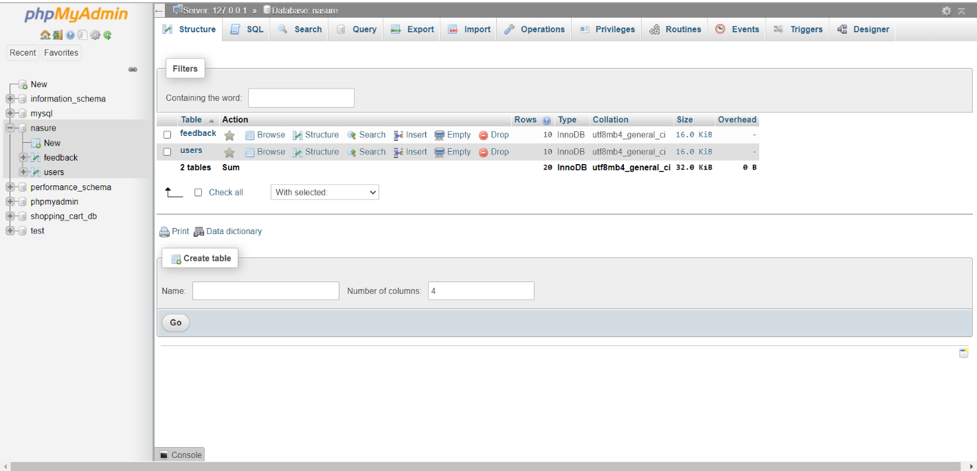

CODE:

CREATE TABLE `feedback` (

  `fname` varchar(50) NOT NULL,

  `lname` varchar(50) NOT NULL,

  `country` varchar(50) NOT NULL,

  `subject` varchar(1000) NOT NULL

) ENGINE=InnoDB DEFAULT CHARSET=utf8mb4;

--

-- Dumping data for table `feedback`

--

INSERT INTO `feedback` (`fname`, `lname`, `country`, `subject`) VALUES

('Aashika', 'B.S.', 'India', 'dfdfbbrgr'),

('nayana', 's.gopal', 'kerala', 'scsdcsdcsdcscs'),

('Aashika', 'B.S.', 'Coimbatore', 'dhjgfjgfhgjgh');

-- --------------------------------------------------------

--

-- Table structure for table `users`

--

CREATE TABLE `users` (

  `ID` int(11) NOT NULL,

  `Uname` varchar(50) NOT NULL,

  `phone_number` bigint(10) NOT NULL,

  `email_id` varchar(50) NOT NULL,

  `password` varchar(50) NOT NULL,

  `clue` varchar(100) NOT NULL

) ENGINE=InnoDB DEFAULT CHARSET=utf8mb4;

--

-- Dumping data for table `users`

--

INSERT INTO `users` (`ID`, `Uname`, `phone_number`, `email_id`, `password`) VALUES

(3616, 'Gnanasundari', 9443407147, 'sundari1234@gmail.com', 'Aashika2002'),

(7311, 'Aashika', 6369397772, 'aashikakrishna4@gmail.com', 'Aashika2542'),

(14204, 'Charunetra', 8870982147, 'charu2079@gmail.com', 'Charu12345'),

(18801, 'Balakrishna', 9489677147, 'krishna47@gmail.com', 'Krishna47'),

(721333028, 'nayana', 6369397772, 'nayana123@gmail.com', 'Nayana1234');

--

-- Indexes for dumped tables

--

--

-- Indexes for table `users`

--

ALTER TABLE `users`

  ADD PRIMARY KEY (`ID`);

--

-- AUTO_INCREMENT for dumped tables

--

--

-- AUTO_INCREMENT for table `users`

--

ALTER TABLE `users`

  MODIFY `ID` int(11) NOT NULL AUTO_INCREMENT, AUTO_INCREMENT=2147483648;

COMMIT;

2.Shopping_cart_db

Constraints: Primary Key, Not null

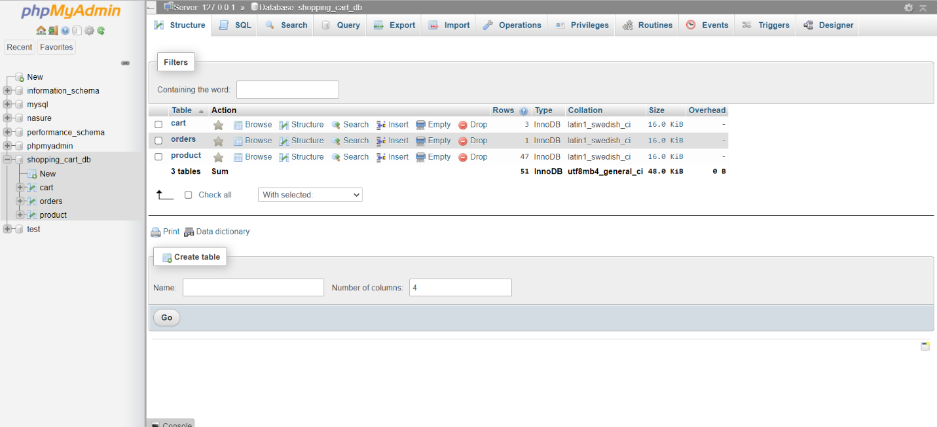

CODE:

CREATE TABLE `cart` (

  `cart_id` int(11) NOT NULL,

  `product_name` varchar(100) NOT NULL,

  `product_price` varchar(50) NOT NULL,

  `product_image` varchar(255) NOT NULL,

  `quantity` int(10) NOT NULL,

  `total_price` varchar(100) NOT NULL,

  `product_code` varchar(10) NOT NULL

) ENGINE=InnoDB DEFAULT CHARSET=latin1;

--

-- Dumping data for table `cart`

--

-- --------------------------------------------------------

--

-- Table structure for table `orders`

--

CREATE TABLE `orders` (

  `order_id` int(11) NOT NULL,

  `username` varchar(100) NOT NULL,

  `email` varchar(100) NOT NULL,

  `phone` varchar(20) NOT NULL,

  `address` varchar(255) NOT NULL,

  `payment_mode` varchar(20) NOT NULL,

  `delivery_type` varchar(30) NOT NULL,

  `products` varchar(255) NOT NULL,

  `paid_amount` varchar(100) NOT NULL,

  `date` timestamp NOT NULL

) ENGINE=InnoDB DEFAULT CHARSET=latin1;

-- --------------------------------------------------------

--

-- Table structure for table `product`

--

CREATE TABLE `product` (

  `product_id` int(11) NOT NULL,

  `product_name` varchar(100) NOT NULL,

  `product_price` varchar(50) NOT NULL,

  `product_image` varchar(255) NOT NULL,

  `product_code` varchar(10) NOT NULL

) ENGINE=InnoDB DEFAULT CHARSET=latin1;

--

-- Dumping data for table `product`

--

INSERT INTO `product` (`product_id`, `product_name`, `product_price`, `product_image`, `product_code`) VALUES

(1, 'FERRY MORSE-Bean Seeds', '85', 'cart-bean.jpg', 'SE101'),

(2, 'MAHYCO-Bittergourd Seeds', '80', 'cart-bittergourd.jpg', 'SE102'),

(3, 'MAHYCO-Brinjal Seeds', '84', 'cart-brinjal.jpg', 'SE104'),

(4, 'MAHYCO-Corn Seeds', '100', 'cart-corn.jpg', 'SE106'),

(5, 'BALAJI-Cucumber Seeds', '90', 'cart-cucumber.jpg', 'SE108'),

(6, 'FLARE-Gooseberry Seeds', '70', 'cart-goose.jpg', 'SE109'),

(7, 'PRUTHVI-Greengram Seeds', '210', 'cart-green.jpg', 'SE110'),

(8, 'FLARE-Guava Seeds', '80', 'cart-guava.jpg', 'SE111'),

(9, 'Imli Seeds', '79', 'cart-imli.jpg', 'SE112'),

(10, 'NIGAM-Okra Seeds', '80', 'cart-lf.jpg', 'SE113'),

(11, 'INDRA-Moong Seeds', '85', 'cart-moong.jpg', 'SE114'),

(12, 'HIND AGRO-Muskmelon Seeds', '75', 'cart-musk.jpg', 'SE115'),

(13, 'CRYSTAL-Paddy Seeds', '240', 'cart-paddy.jpg', 'SE116'),

(14, 'HERBAL GOODNESS-Papaya Seeds', '65', 'cart-papaya.jpg', 'SE117'),

(15, 'ROYAL-Peas Seeds', '90', 'pea1.jpg', 'SE118'),

(16, 'NATUREWELL-Pumpkin Seeds', '65', 'cart-pumpkin.jpg', 'SE119'),

(17, 'BALAJI-Ridgegourd Seeds', '72', 'cart-ridge.jpg', 'SE120'),

(18, 'SIKKO-Tomato Seeds', '85', 'cart-tomato.png', 'SE121'),

(19, 'ICON-Watermelon Seeds', '95', 'cart-water.jpg', 'SE122'),

(20, 'CHANDHAN-Mustard Seeds', '80', 'MUST.jpg', 'SE123'),

(21, 'MAHYCO-Bottlegourd Seeds', '85', 'bottle.jpg', 'SE103'),

(22, 'VNR-Chilli Seeds', '75', 'cart-chi.png', 'SE105'),

(23, 'CRYSTAL-Cotton Seeds', '538', 'cart-cot.jpg', 'SE107'),

(24, 'FARM SEEDS-Onion Seeds', '75', 'ONION.jpeg', 'SE124'),

(25, 'MANI DHARMA-Panchagavya', '85', '5kavya.jpg', 'F101'),

(26, 'GREEN OZEN-Panchagavya', '80', '5kavya1.jpg', 'F102'),

(27, 'PANCHA RATHNA-Panchgavya', '84', '5kavya3.jpg', 'F103'),

(28, 'PIONEER AGRO-Azosprillum', '100', 'azo1.jpg', 'F104'),

(29, 'MBF-Azosprillum', '90', 'azo2.jpg', 'F105'),

(30, 'BANNARI AMMAN-Biocompost', '70', 'bio1.jpg', 'F106'),

(31, 'RANADEY-Boracol BSF-11', '210', 'boracol.jpg', 'F107'),

(32, 'SPIC-DAP', '80', 'dap.jpg', 'F108'),

(33, 'IPL-Potash', '79', 'ipl-potash.jpg', 'F109'),

(34, 'RANADEY-Kiecite RFC', '80', 'kiecite.jpg', 'F110'),

(35, 'ULTRA GOLD-Liquid Fertilizer', '85', 'liqui fers.jpg', 'F111'),

(36, 'LINGA CHEMICALS-Micronol', '75', 'micronol.jpg', 'F112'),

(37, 'MANI DHARMA-Phosphobacteria', '240', 'phospho.jpg', 'F113'),

(38, 'ABTEC-Phosphobacteria', '65', 'phospho1.jpg', 'F114'),

(39, 'GREENSTAR-Potassium Schoenite', '90', 'posh.jpg', 'F115'),

(40, 'ESAF-Pseudomonas', '65', 'pseudo.jpg', 'F116'),

(41, 'BAKASHI BRAN-Pseudomonas', '72', 'pseudo1.jpg', 'F117'),

(42, 'GREENMYLIFE-Pseudomonas', '85', 'pseudo2.jpg', 'F118'),

(43, 'RANADEY-Rasokal', '95', 'rasokol.jpg', 'F119'),

(44, 'NICO ORGO-Trichoderma Viride', '80', 'tricho.jpg', 'F120'),

(45, 'UTKARSH-Trichoderma Viride',  '85','tricho1.jpg','F121'),

(46, 'SPIC-Urea', '75', 'urea.jpg','F122'),

(47, 'GARDENGOLD-Vermicompost','538','vc.jpg','F123');

--

-- Indexes for dumped tables

--

--

-- Indexes for table `cart`

--

ALTER TABLE `cart`

  ADD PRIMARY KEY (`cart_id`);

--

-- Indexes for table `orders`

--

ALTER TABLE `orders`

  ADD PRIMARY KEY (`order_id`);

--

-- Indexes for table `product`

--

ALTER TABLE `product`

  ADD PRIMARY KEY (`product_id`);

--

-- AUTO_INCREMENT for dumped tables

--

--

-- AUTO_INCREMENT for table `cart`

--

ALTER TABLE `cart`

  MODIFY `cart_id` int(11) NOT NULL AUTO_INCREMENT, AUTO_INCREMENT=100;

--

-- AUTO_INCREMENT for table `orders`

--

ALTER TABLE `orders`

  MODIFY `order_id` int(11) NOT NULL AUTO_INCREMENT, AUTO_INCREMENT=100;

--

-- AUTO_INCREMENT for table `product`

--

ALTER TABLE `product`

  MODIFY `product_id` int(11) NOT NULL AUTO_INCREMENT, AUTO_INCREMENT=100;

UI DESIGN SCREEN SHOTS:

**1.HOME PAGE**



**2.OUR STORY:**



**3.LOCATE US AT:**

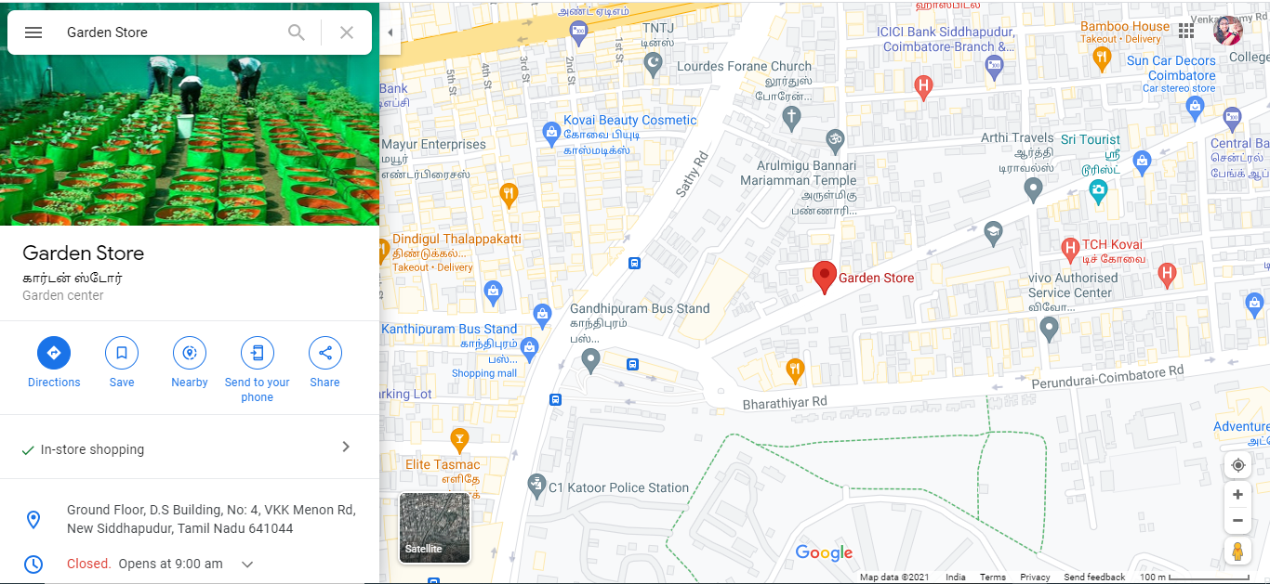

**4.CONTACT US:**



**5.LOGIN PAGE:**



**6.SIGNUP PAGE**

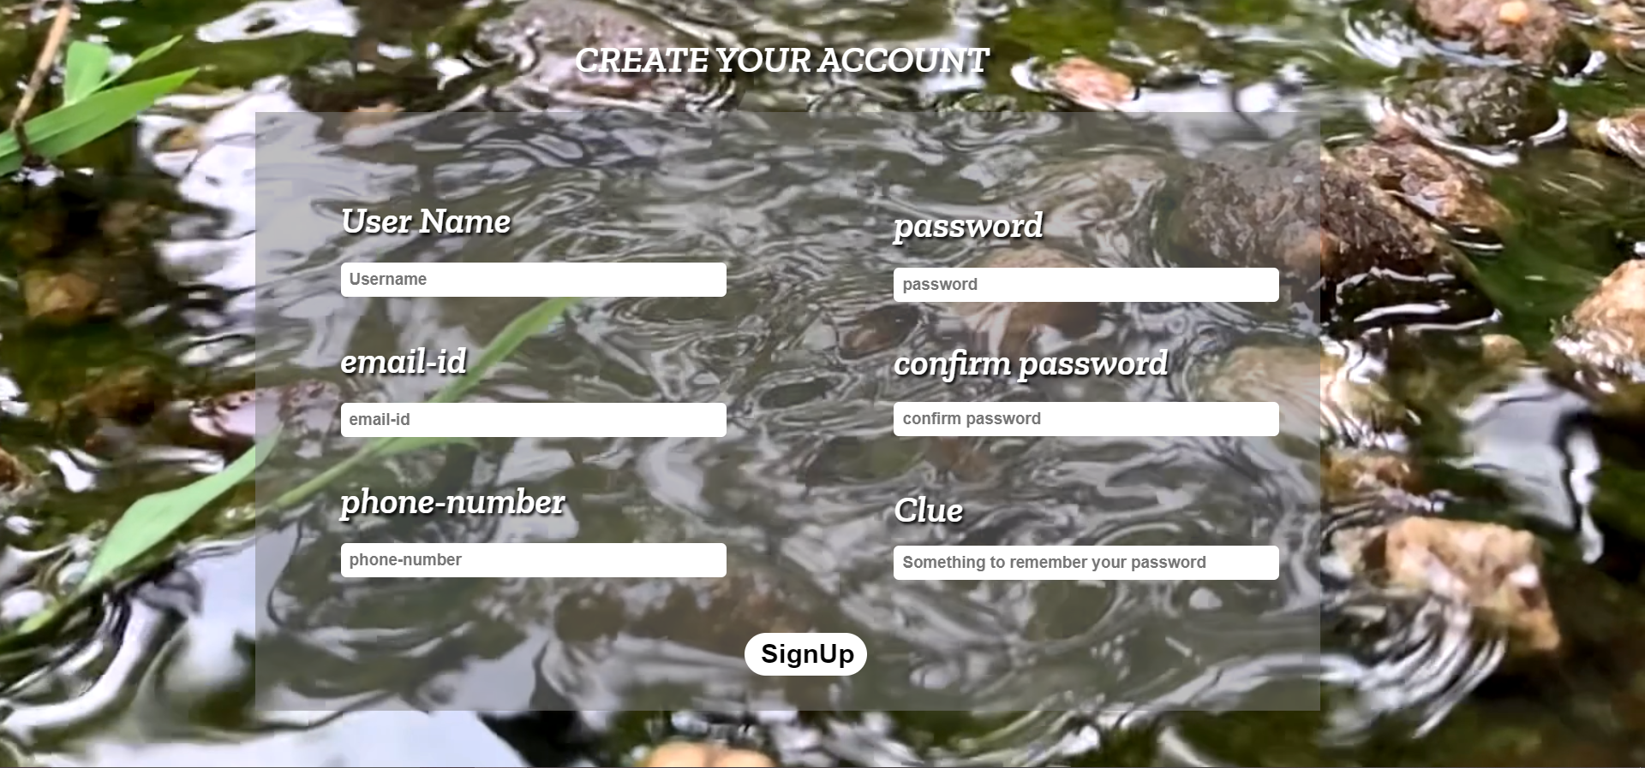

**THROWS ERROR IF EMAIL ALREADY EXISTS**



**IF THE EMAIL IS UNIQUE**



**FORGOT PASSWORD PAGE:**



**CLUE FOR PASSWORD**



**7.ORDER PAGE:**

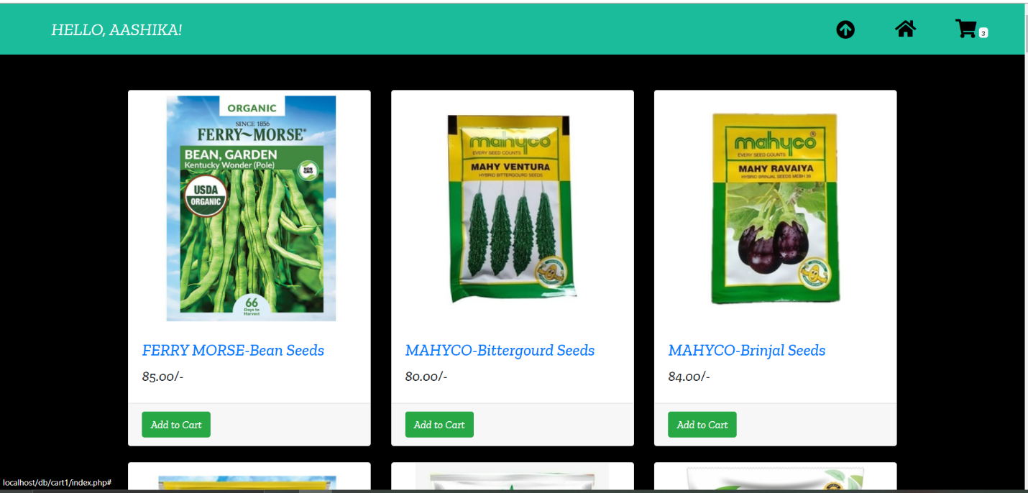

**8.CART**

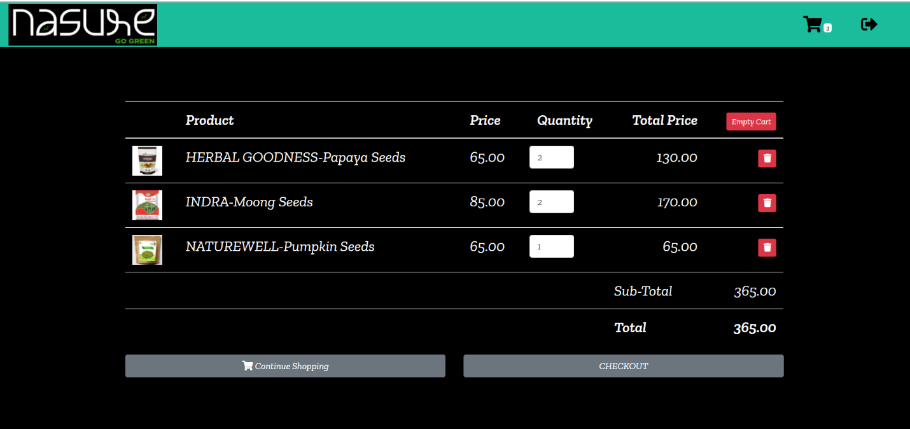

**9.CHECK OUT PAGE:**

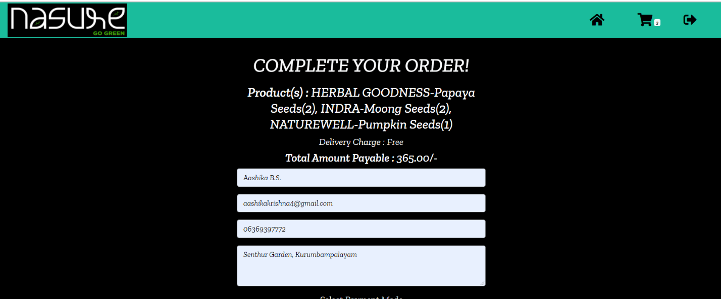

**10.CONFIRMATION PAGE:**



**UI PROJECT CODE:**

**1.HOME PAGE:**

**Html and javascript**

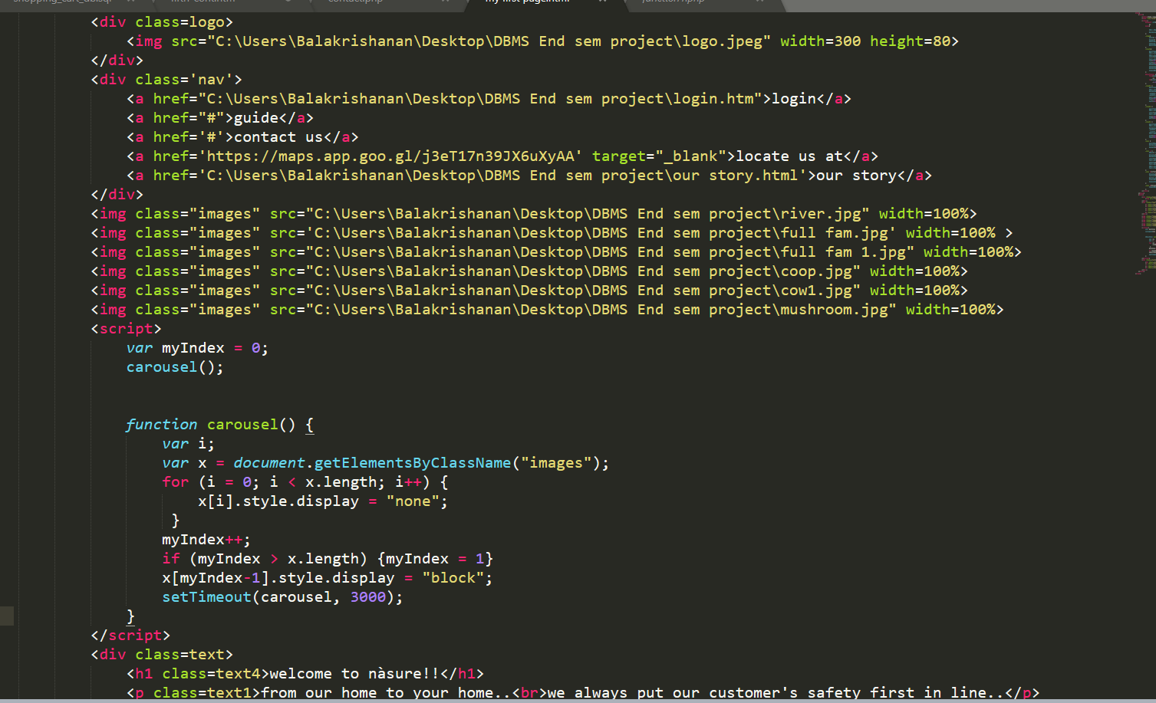

**Css:**

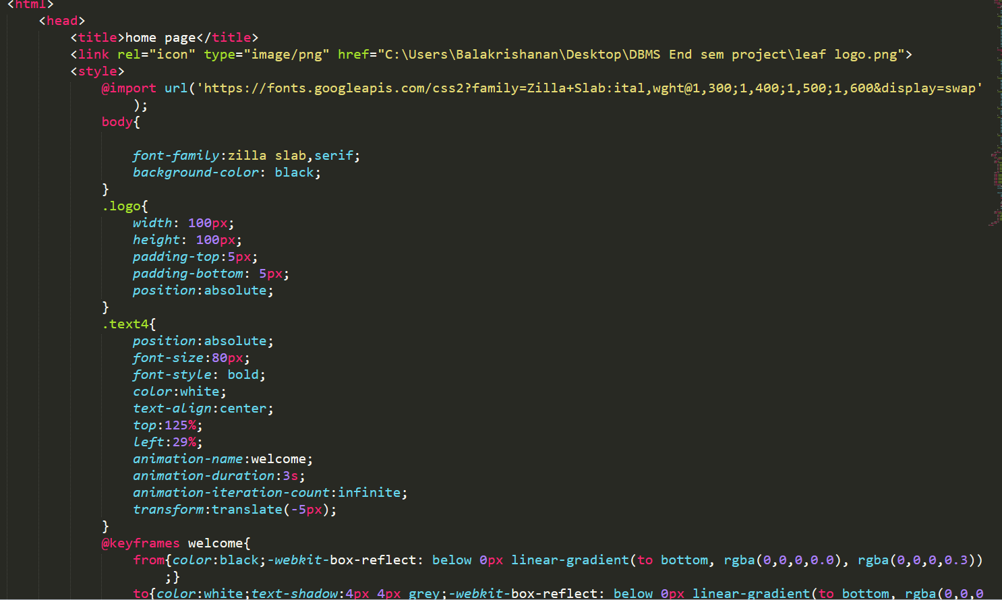

**2.OUR STORY**

**Html:**

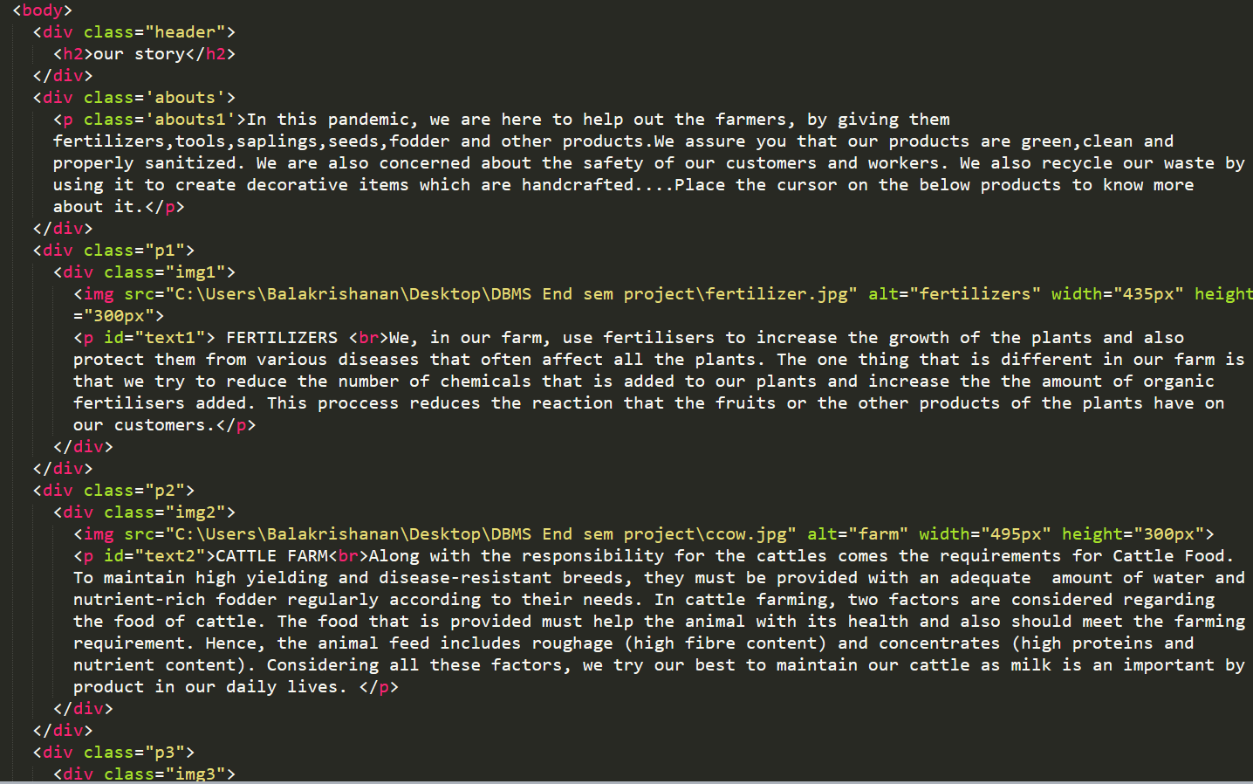

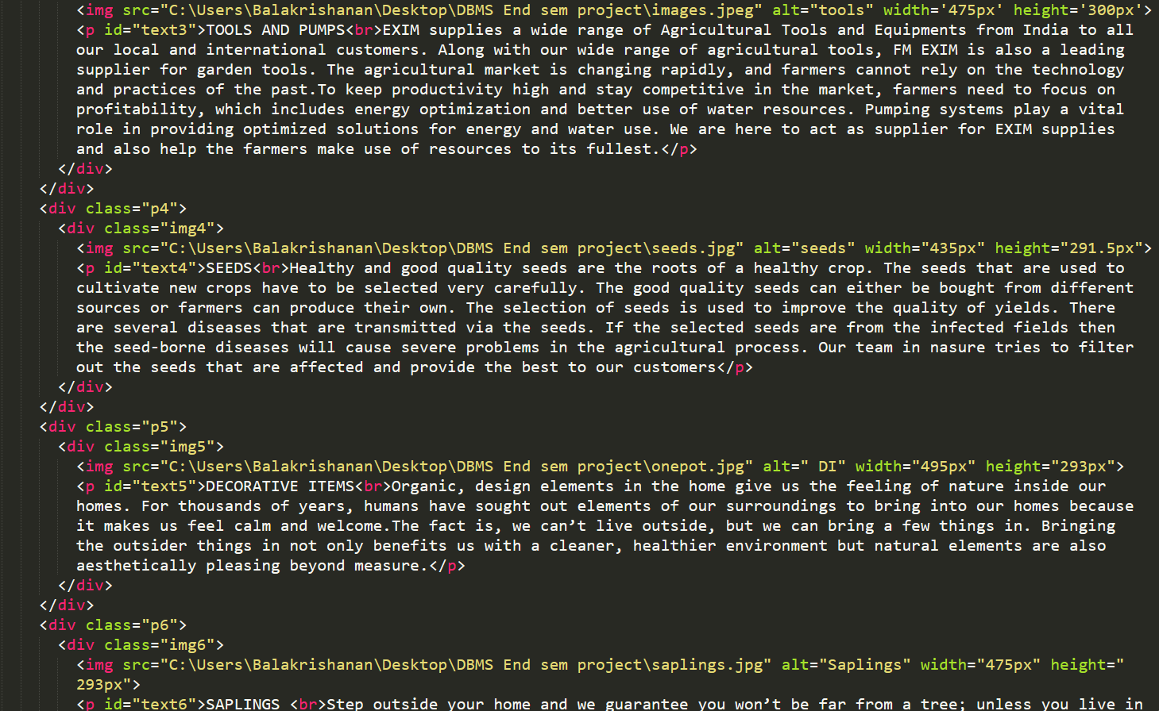

**Css:**

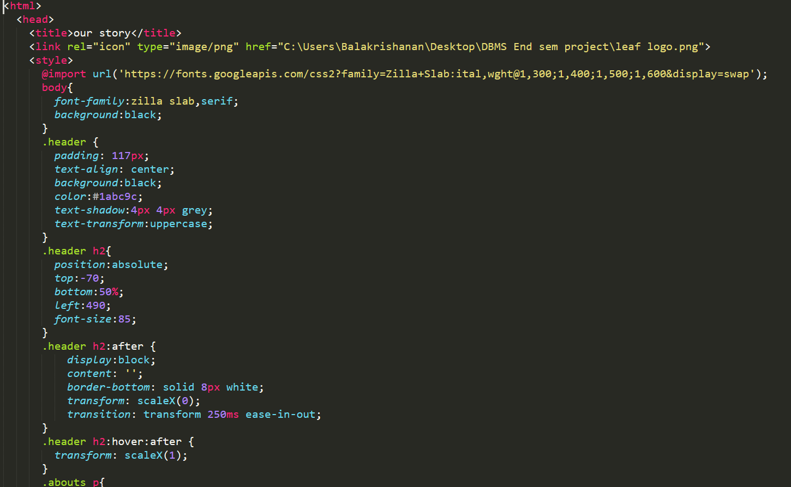



**CONTACT US PAGE:**

**Html and javascript:**

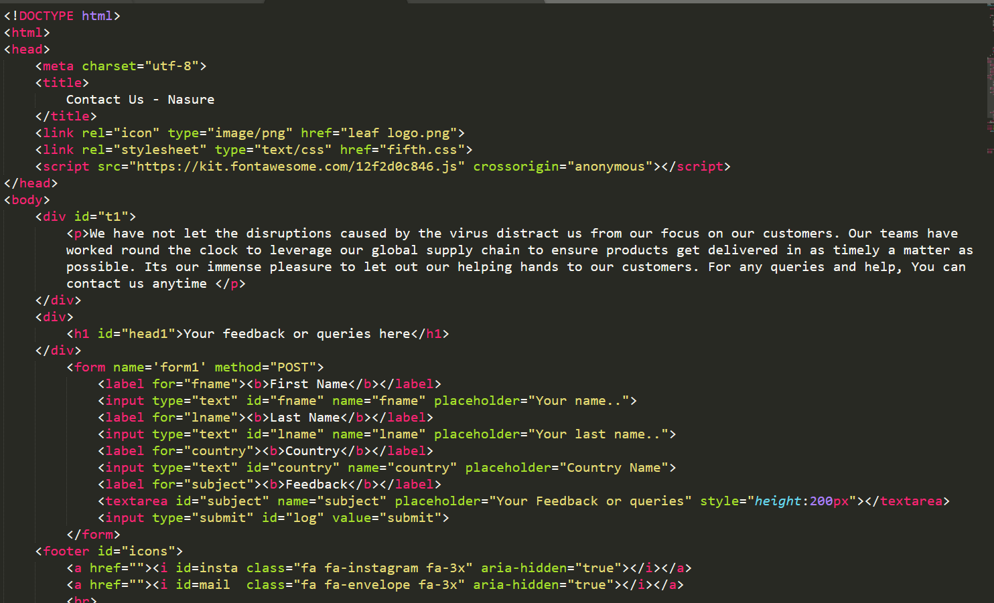

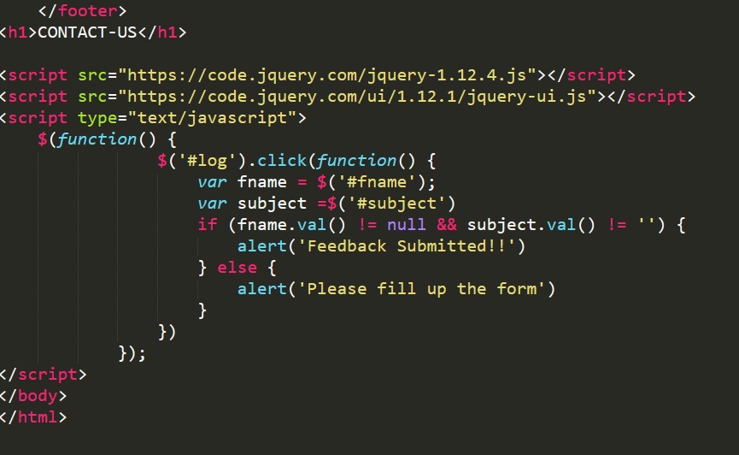

**css:**

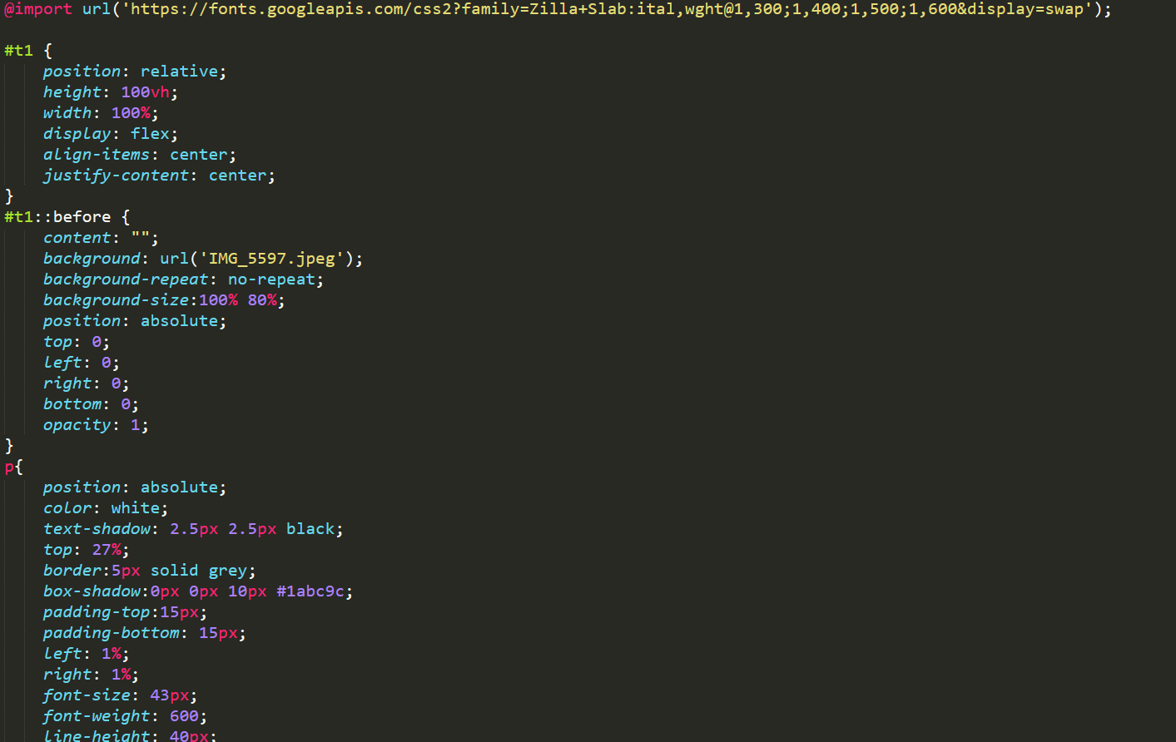

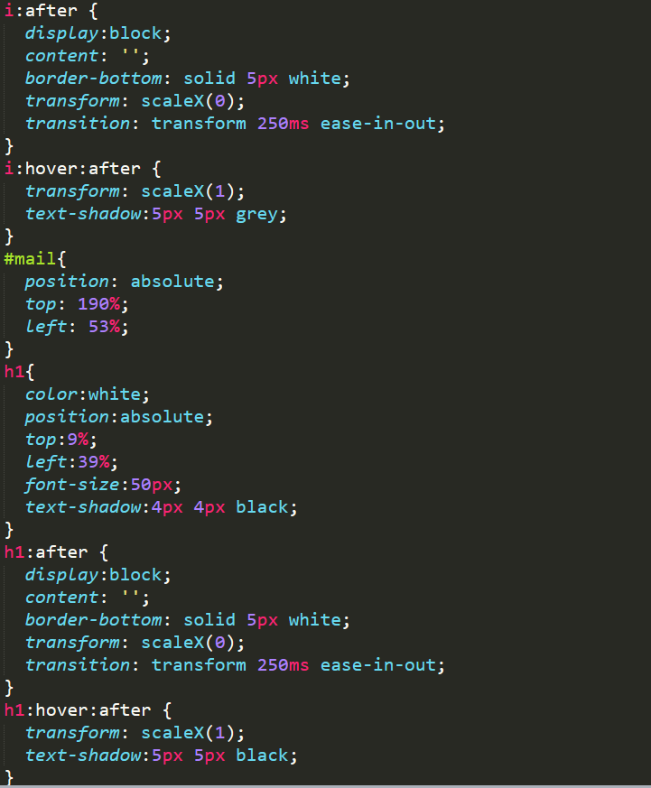

**SIGN UP PAGE:**

**html:**

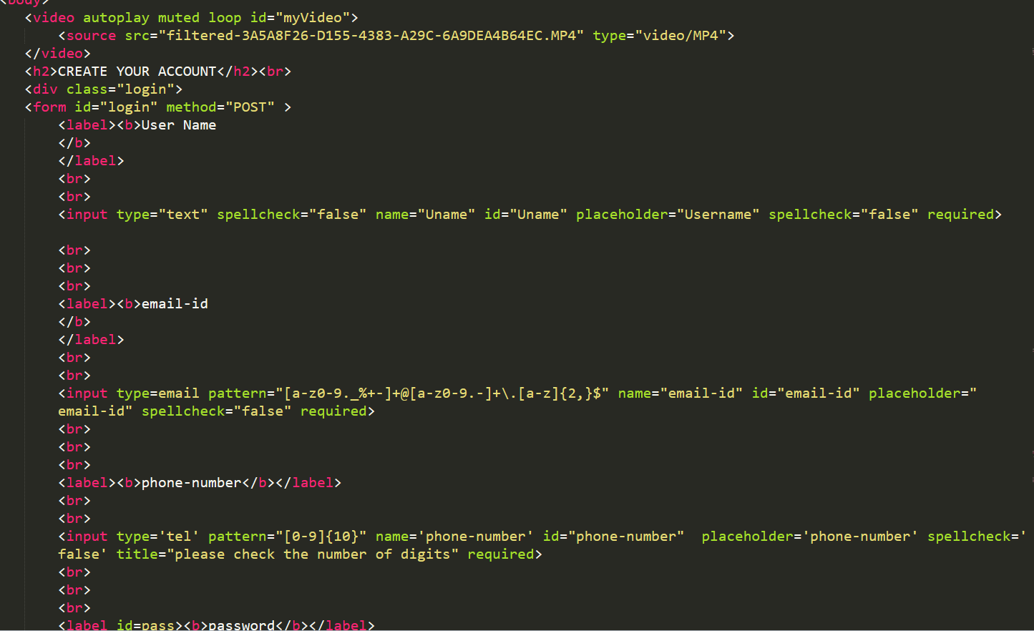

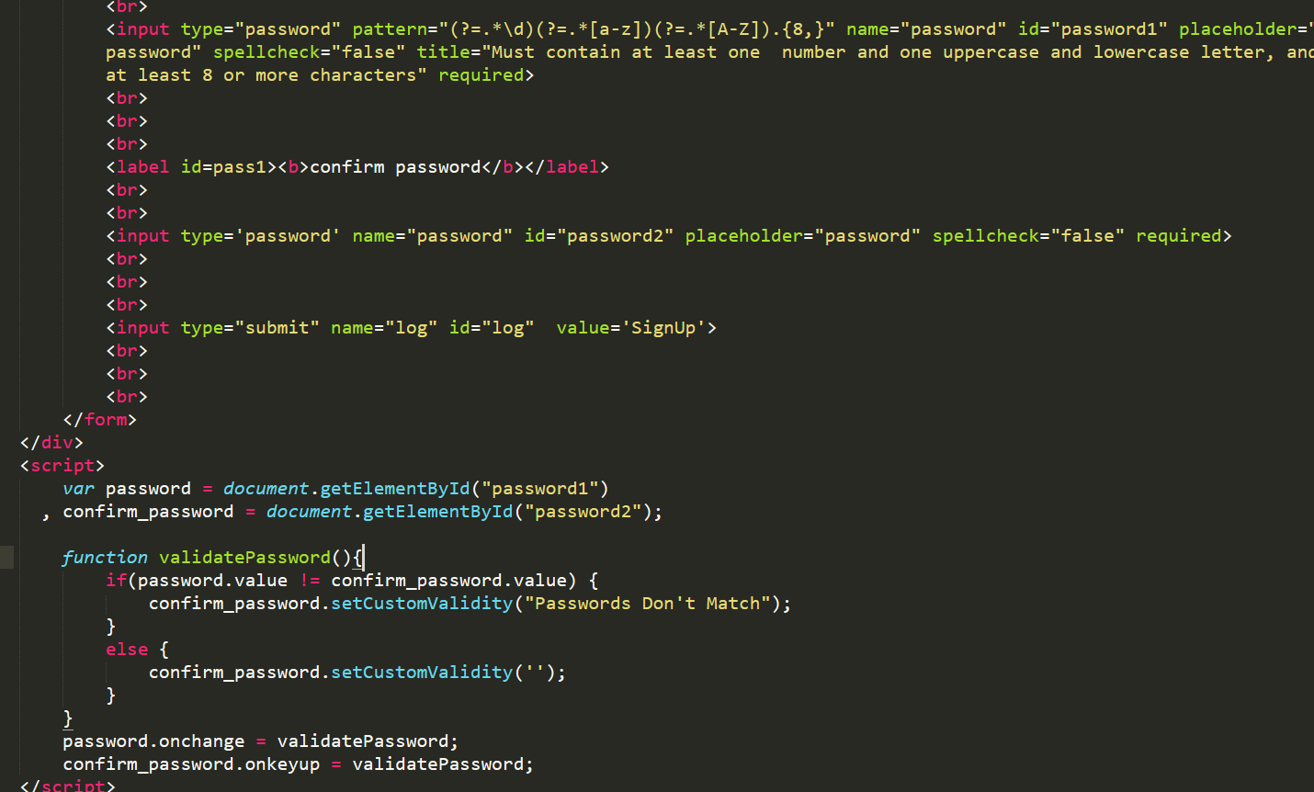

**css:**

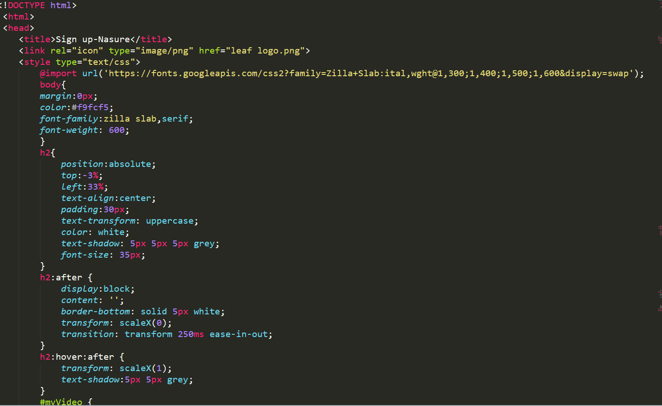

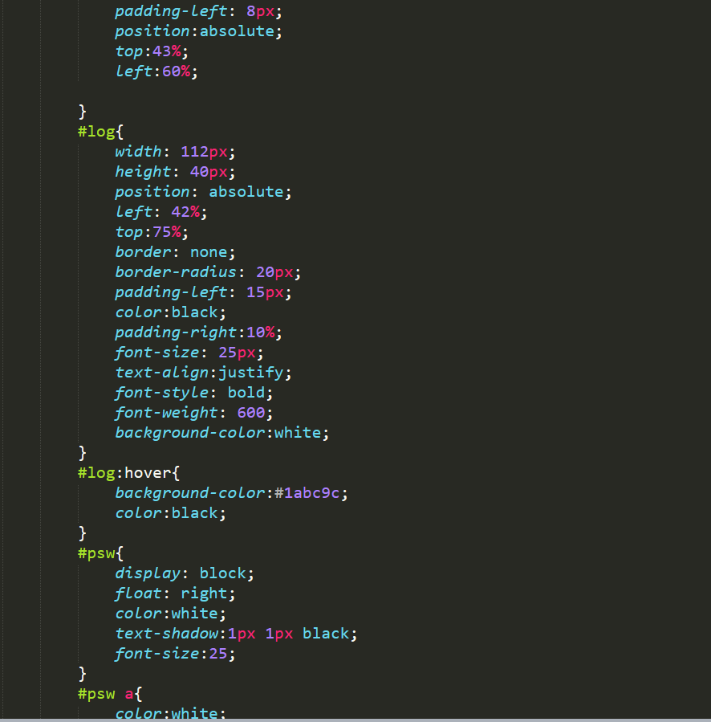

**LOGIN PAGE:**

**html:**

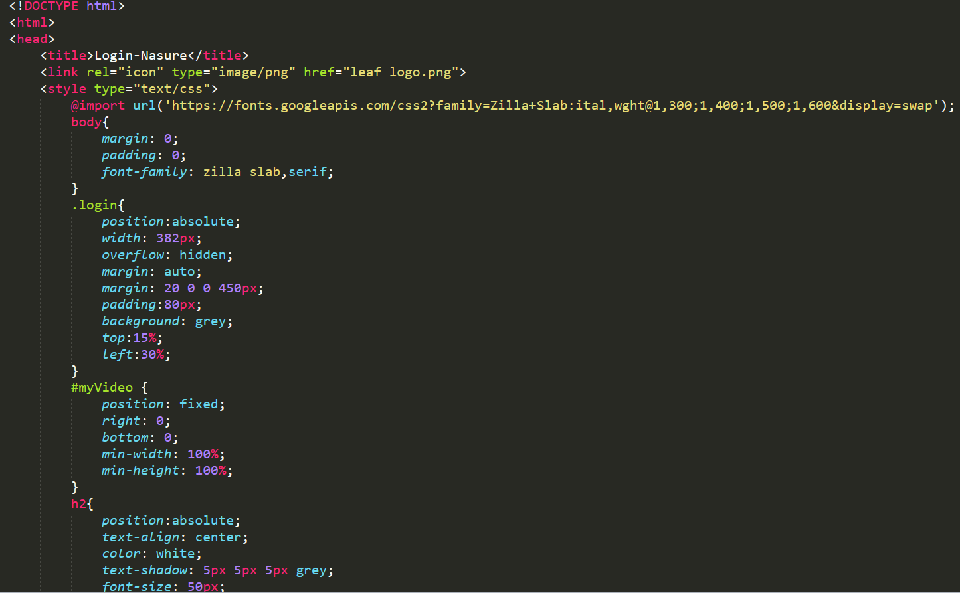

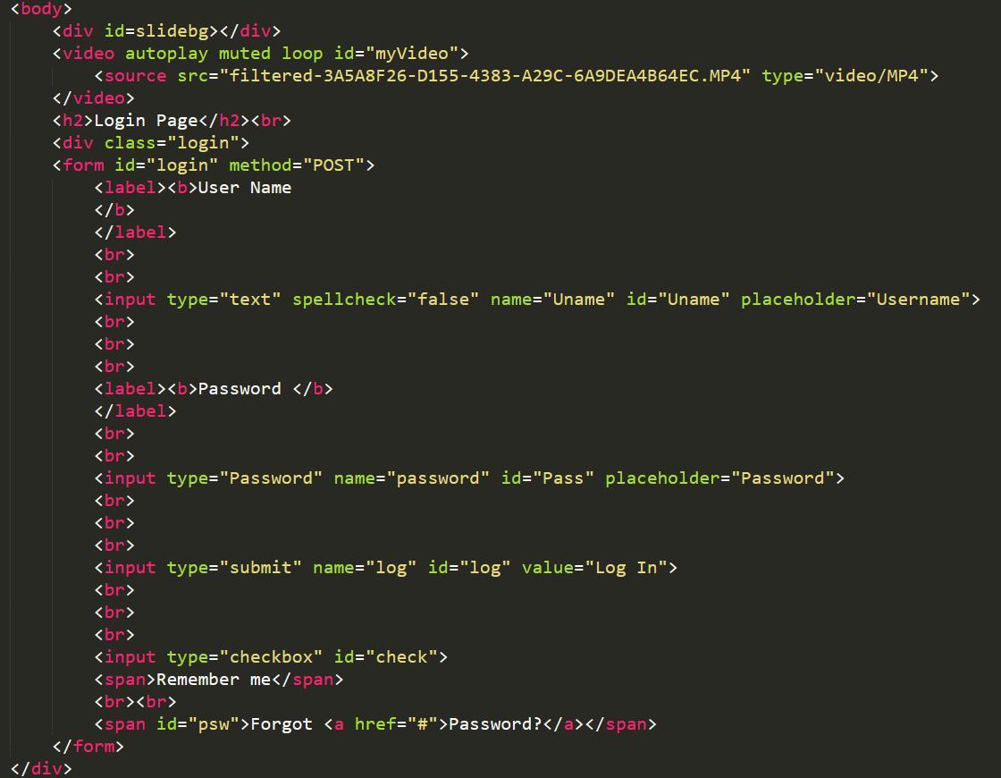

**css:**

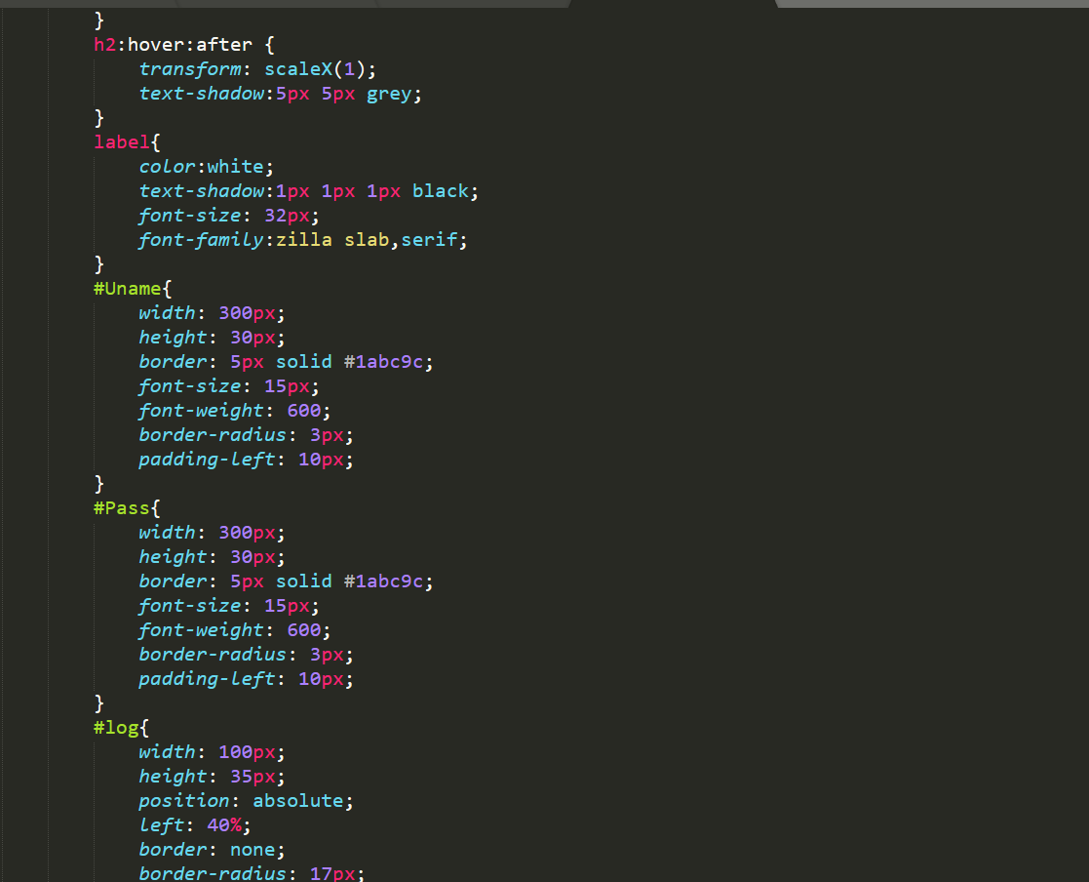

**CHECKING THE EMAIL ID TO BE UNIQUE:**

**php:**

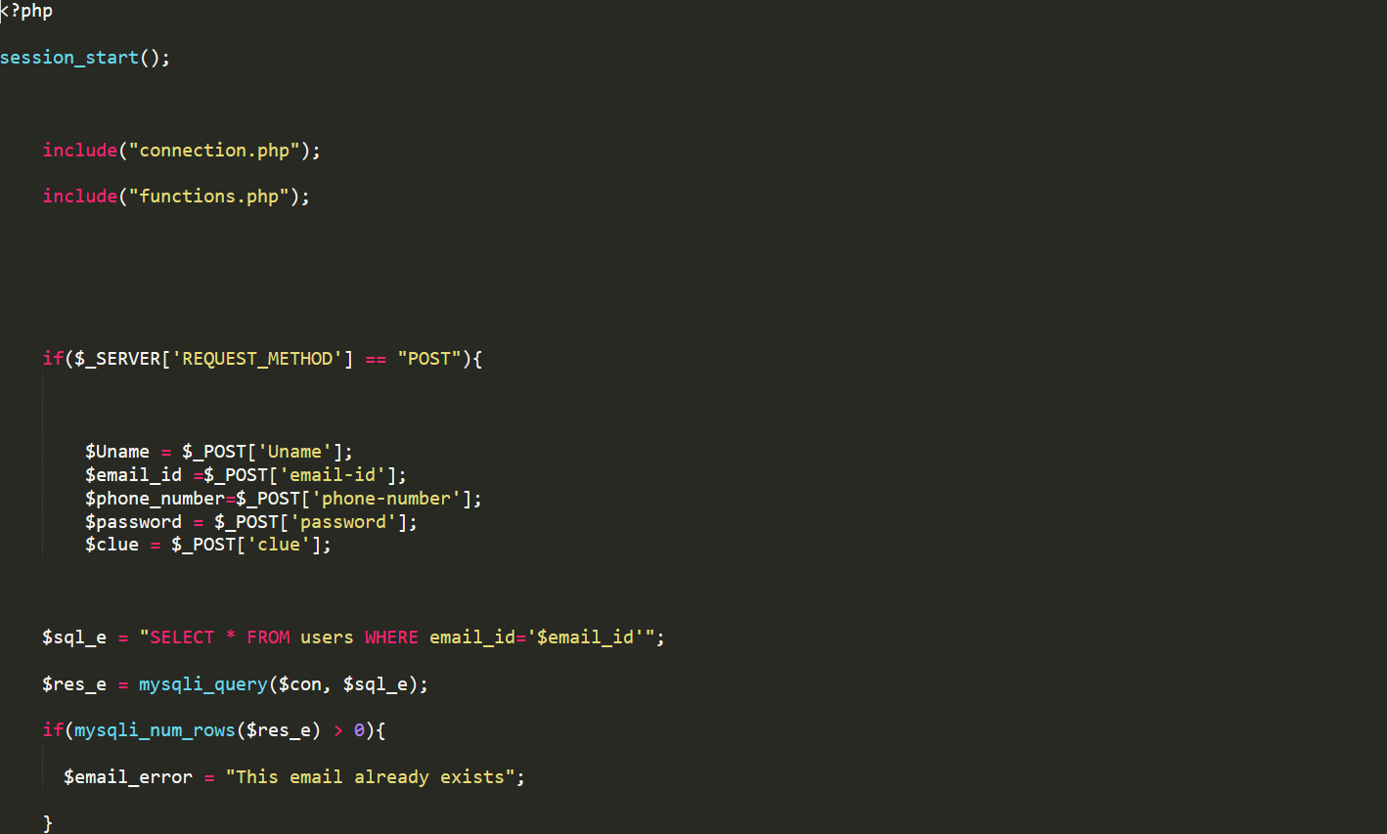

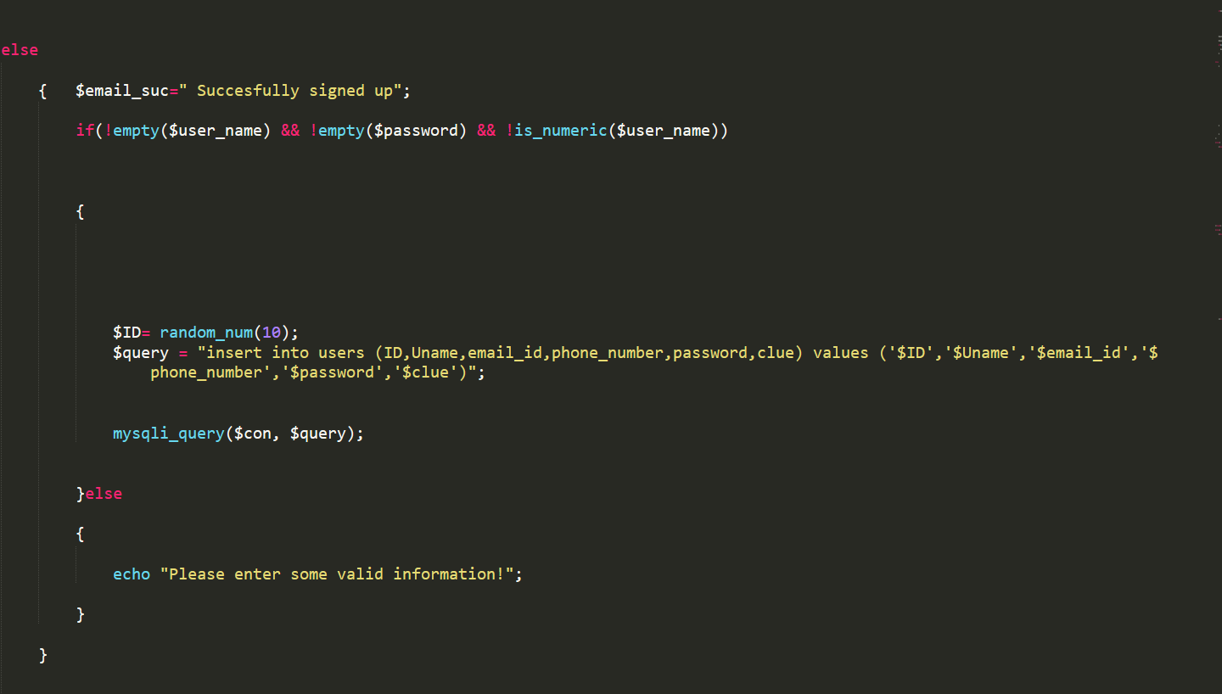

**css:**

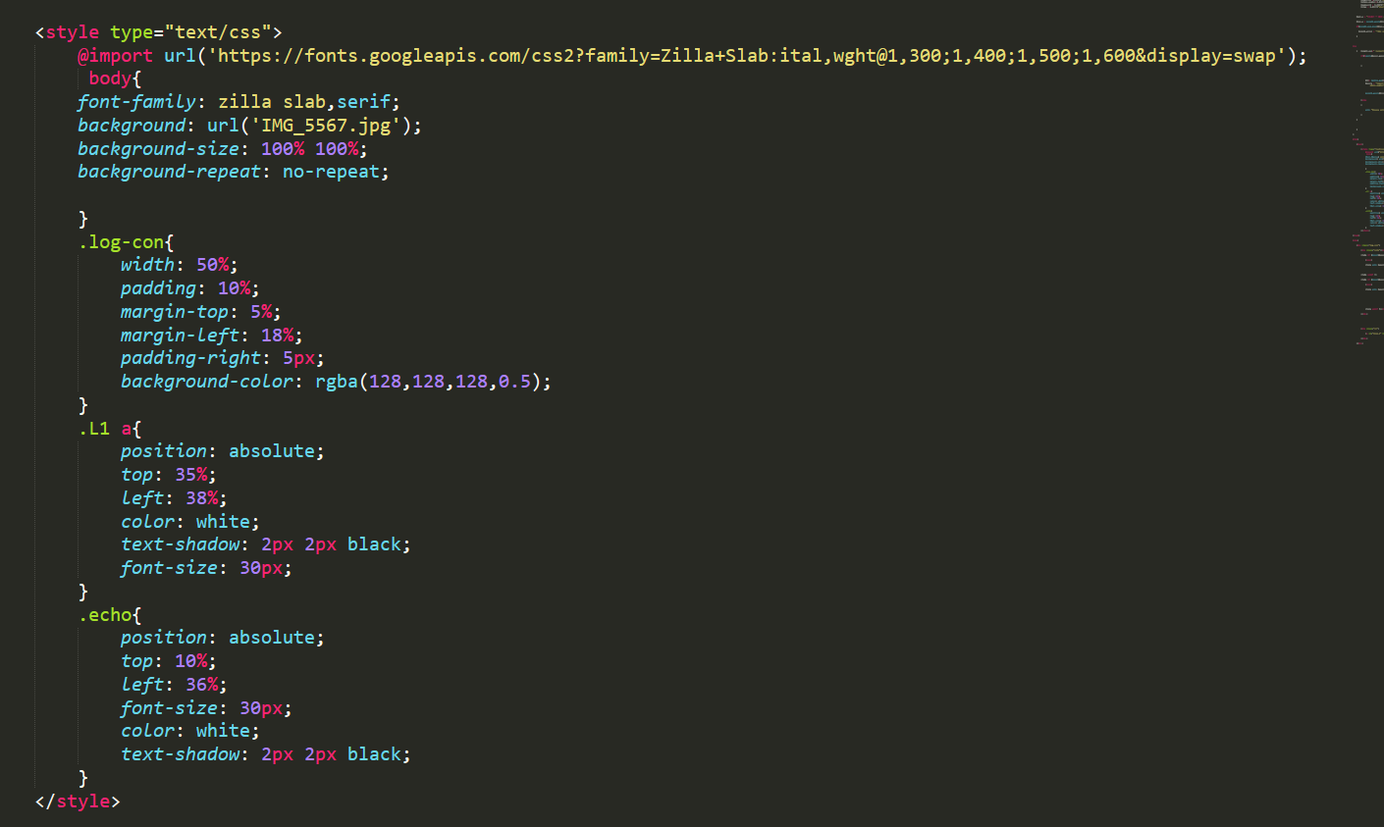

**html:**

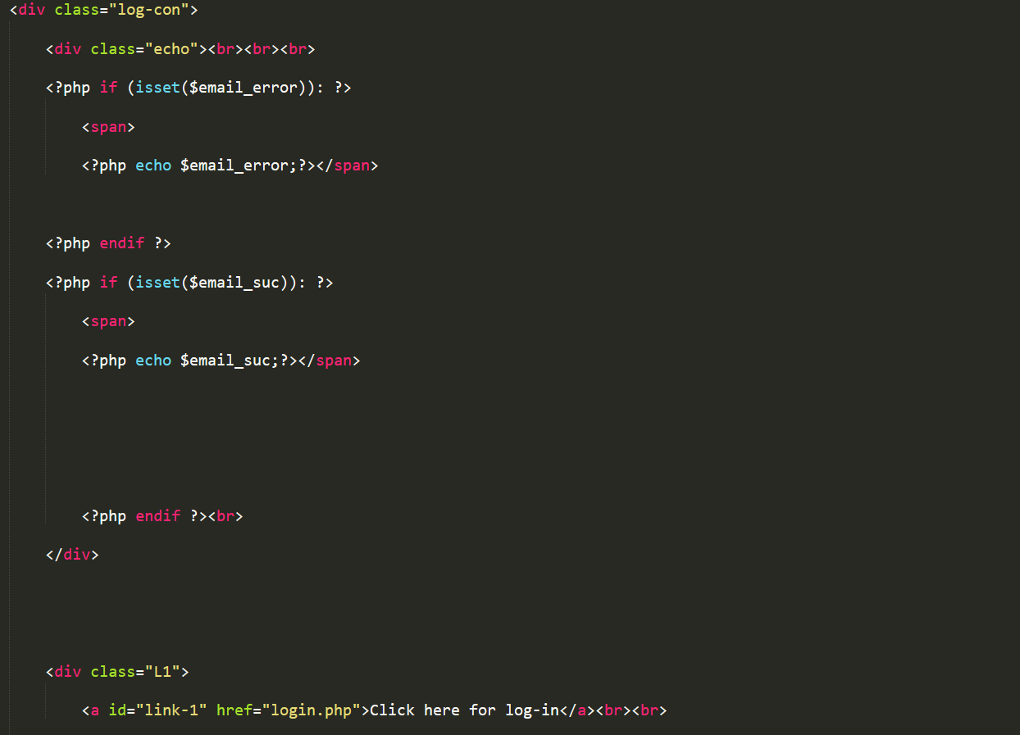

**FORGOT PASSWORD :**

**html:**

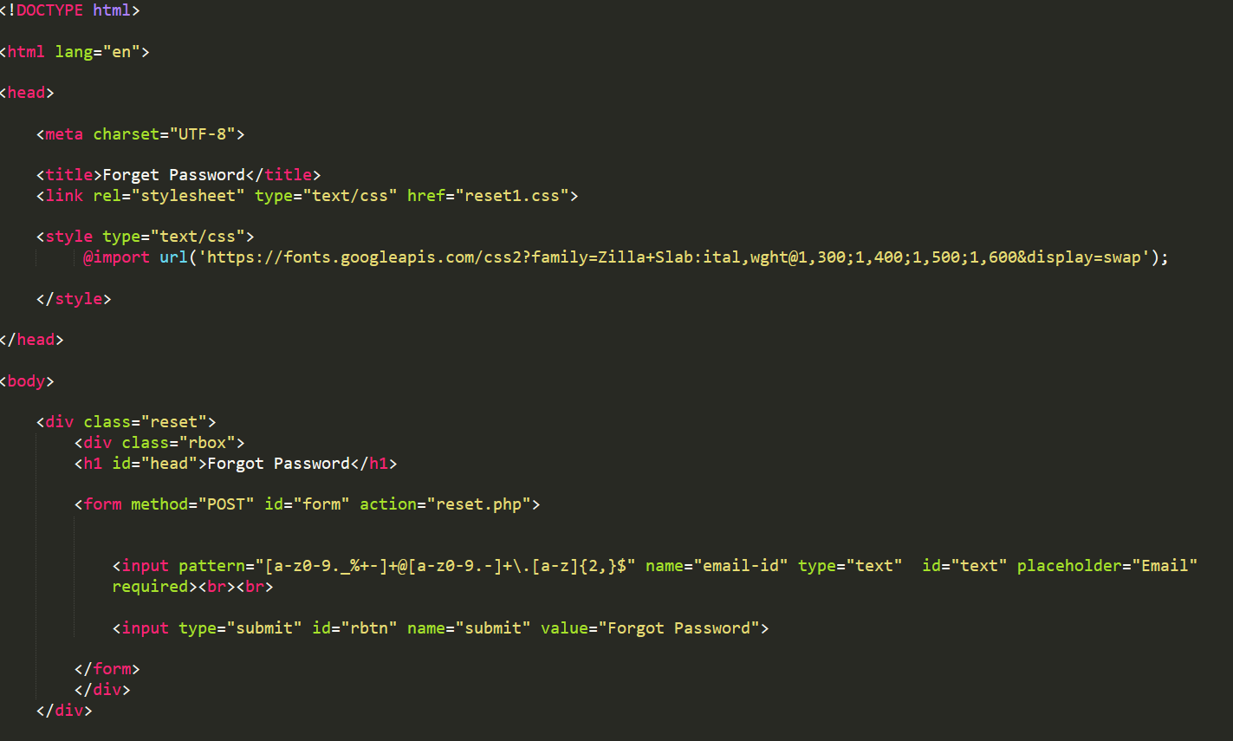



**CSS:**

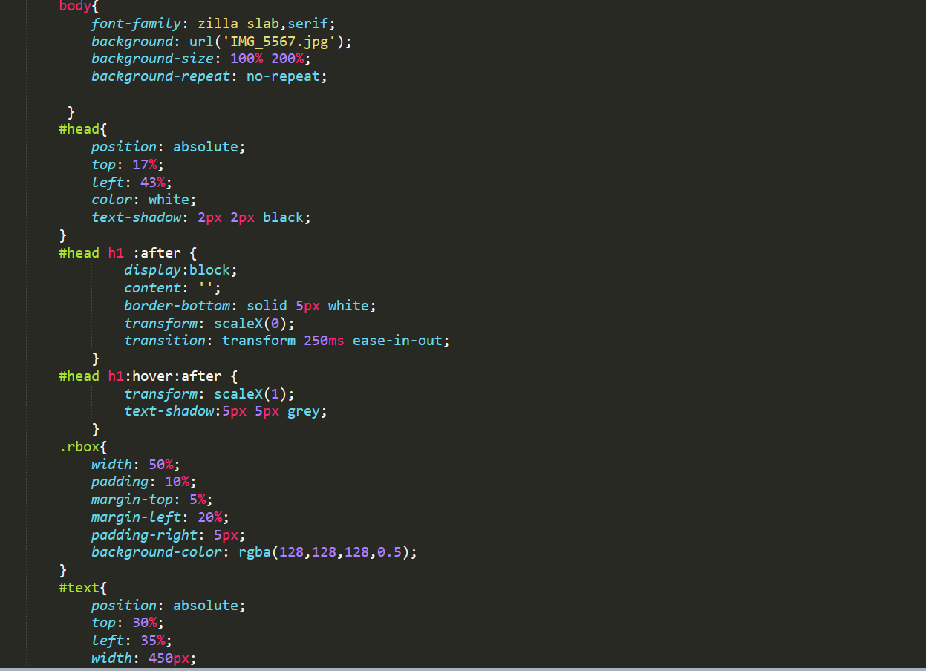

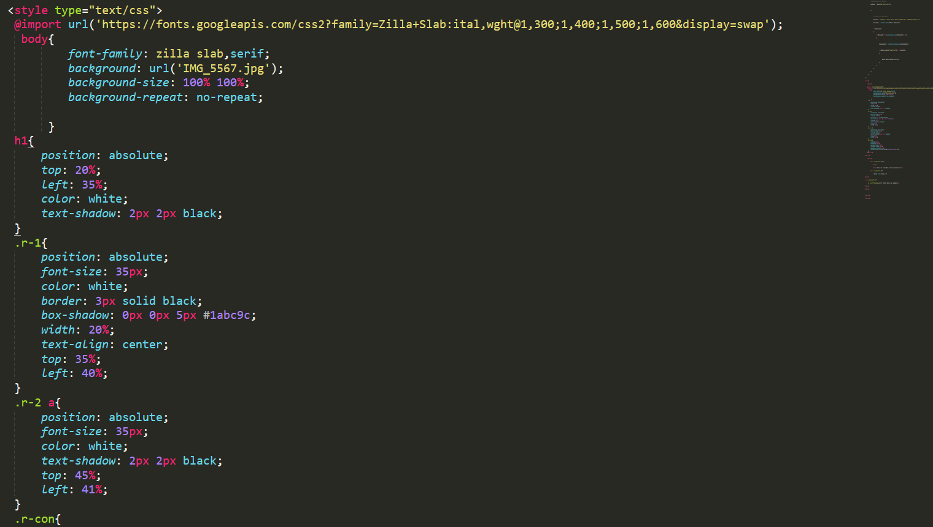

**php:**

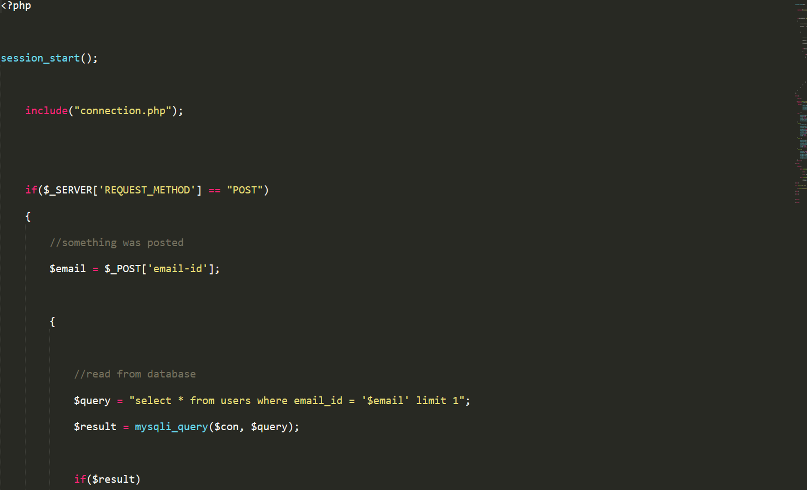

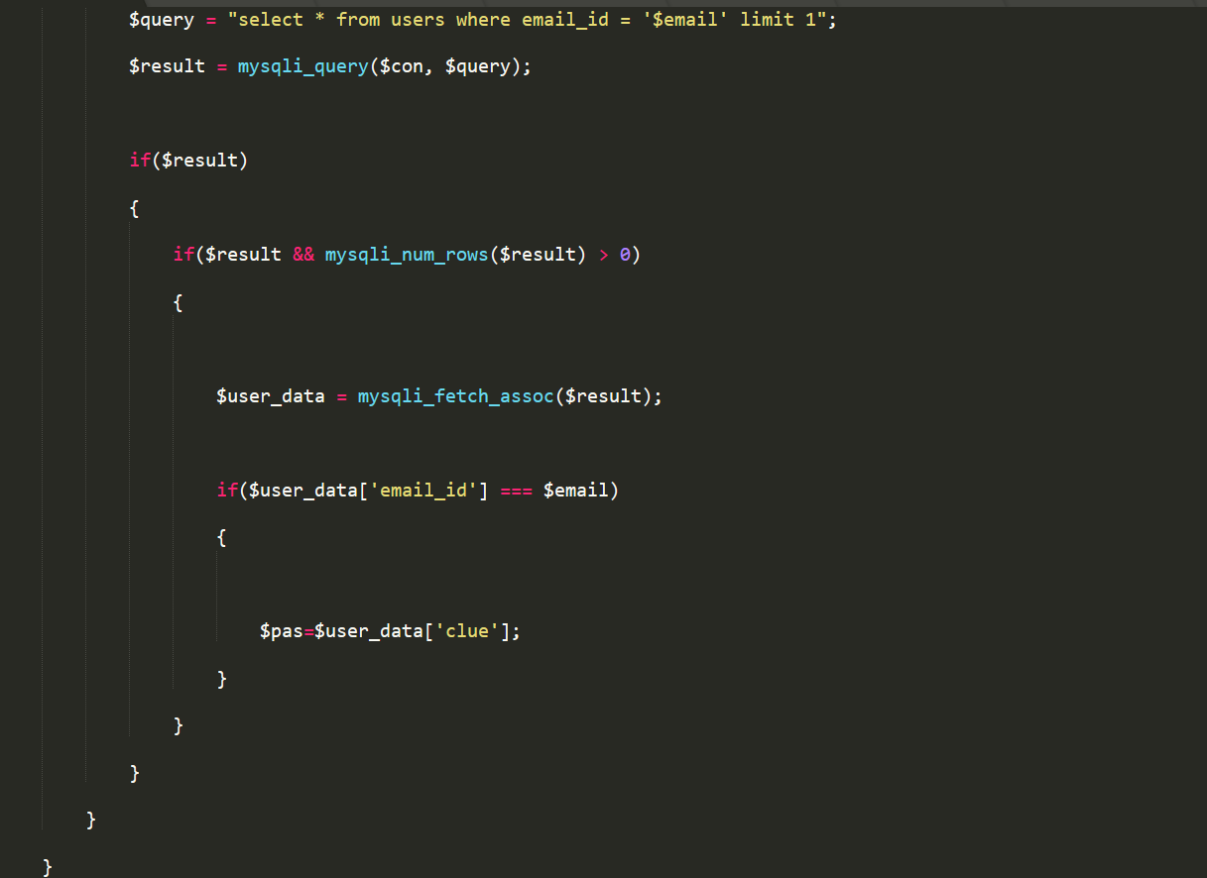

**CART PAGE:**

**html and JS:**

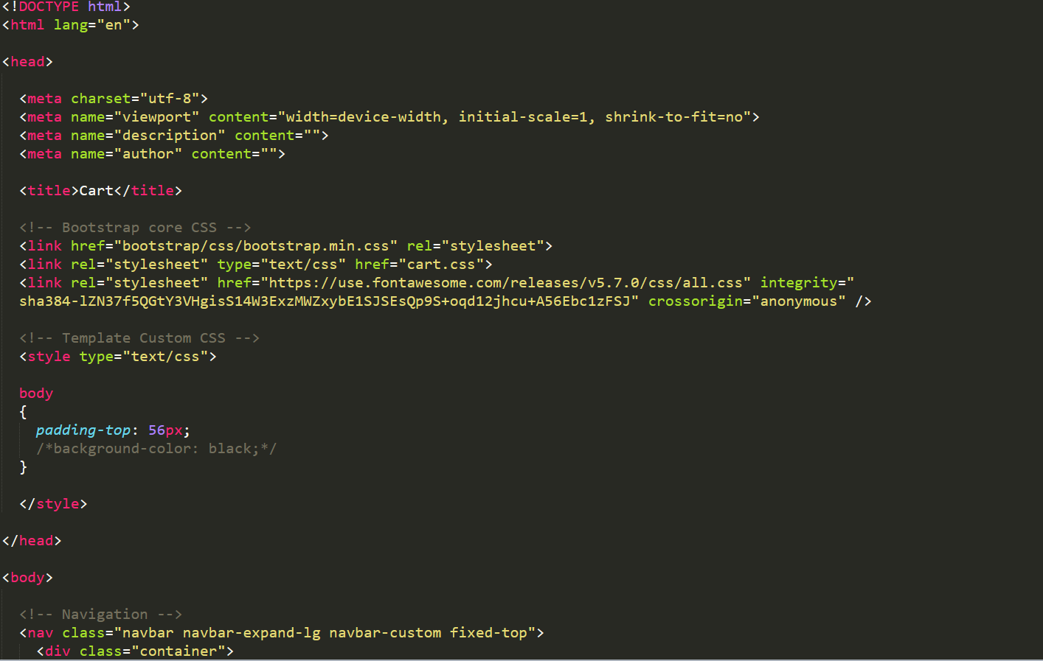

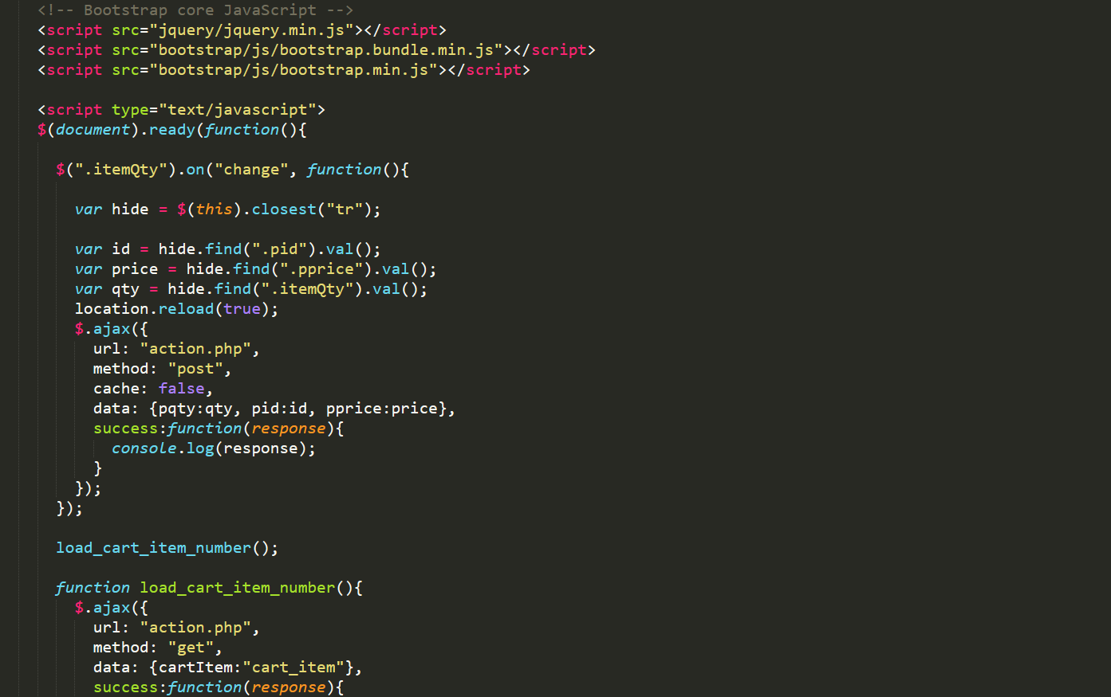

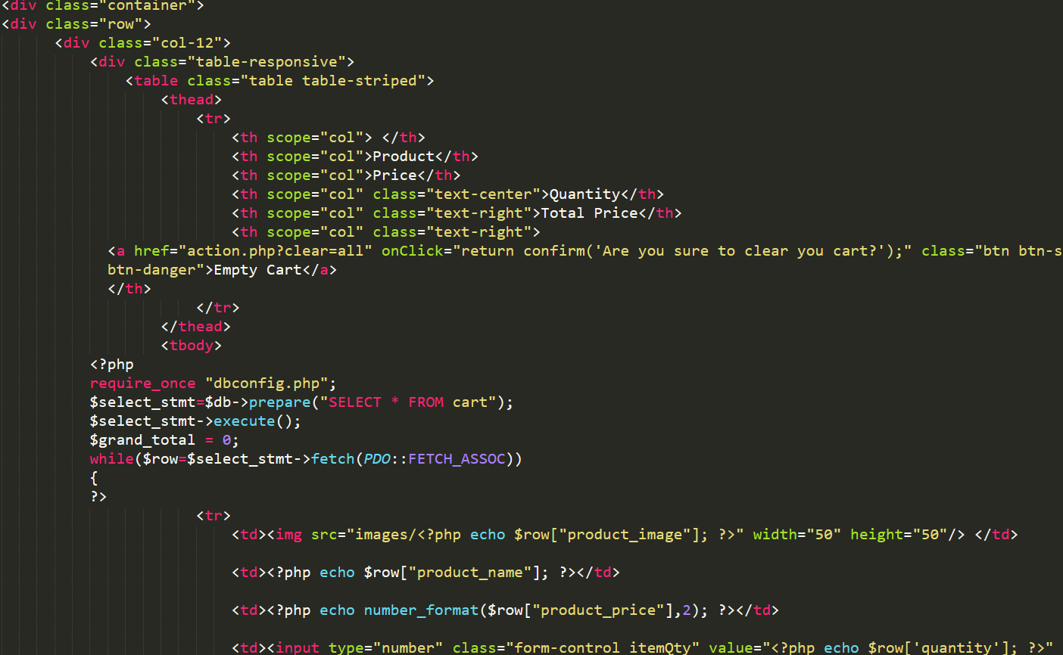

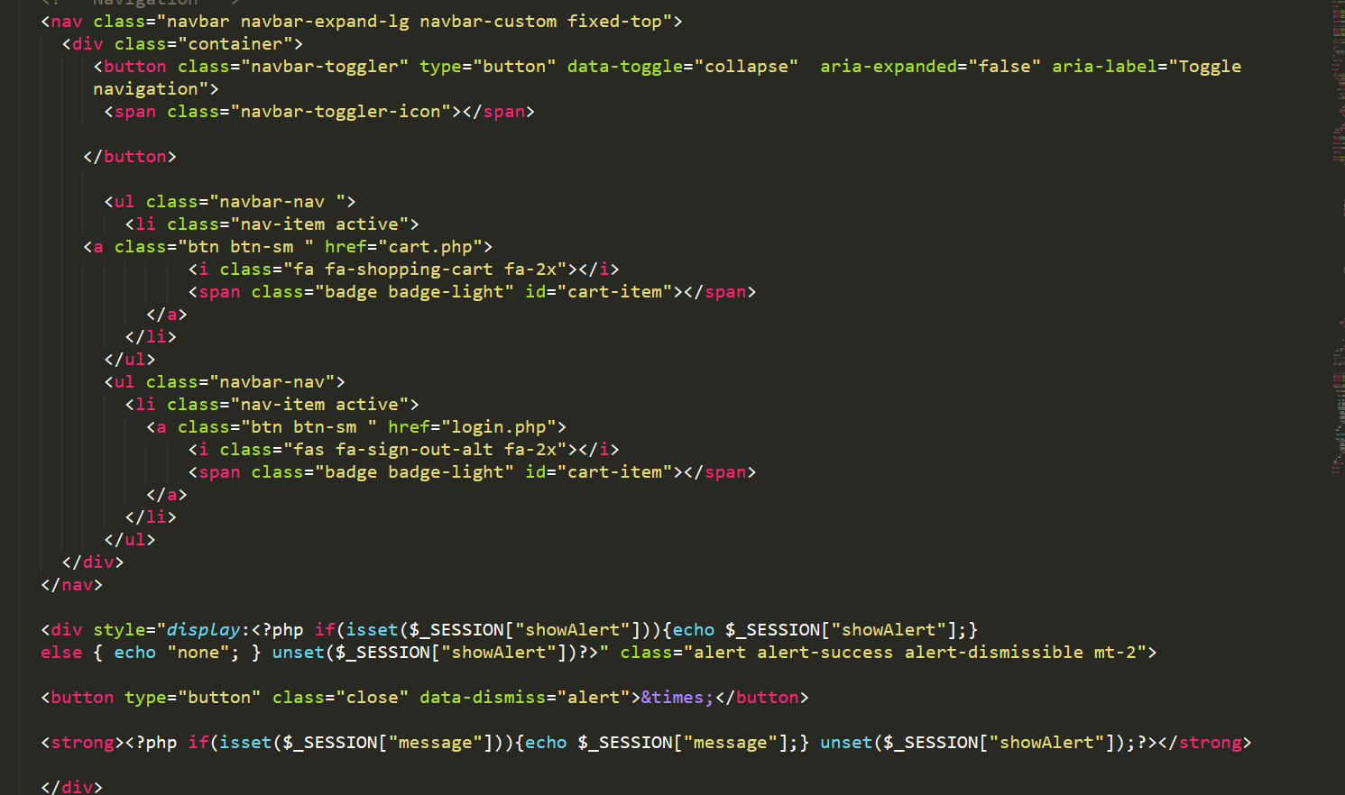

**Css:**

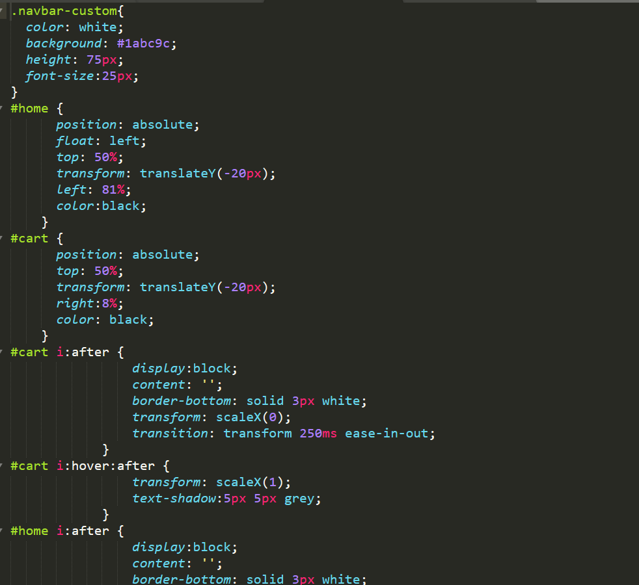

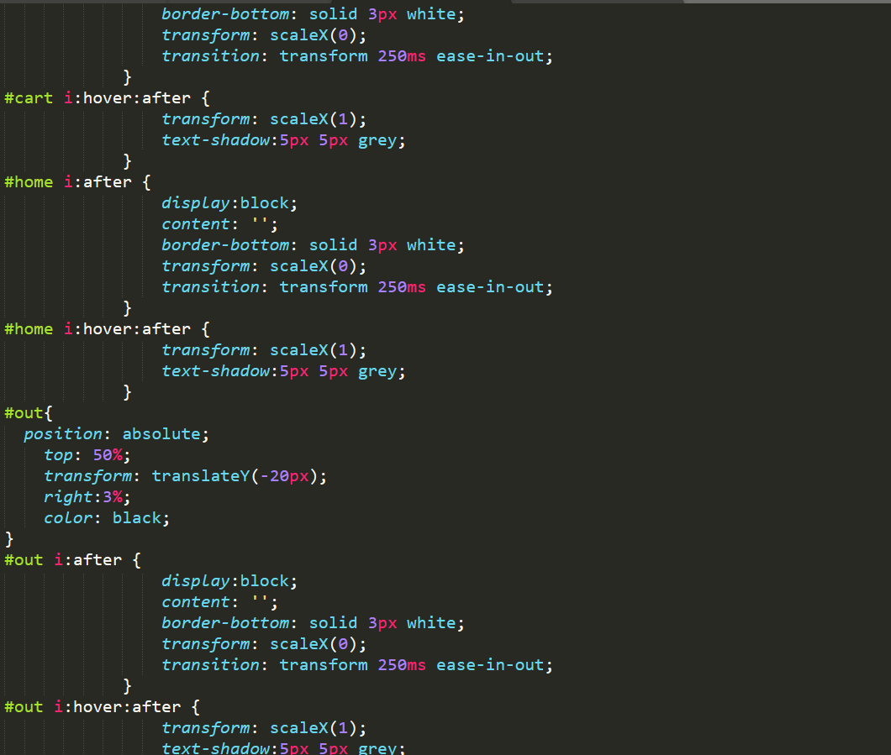

**CHECK OUT PAGE:**

**Html and javascript**

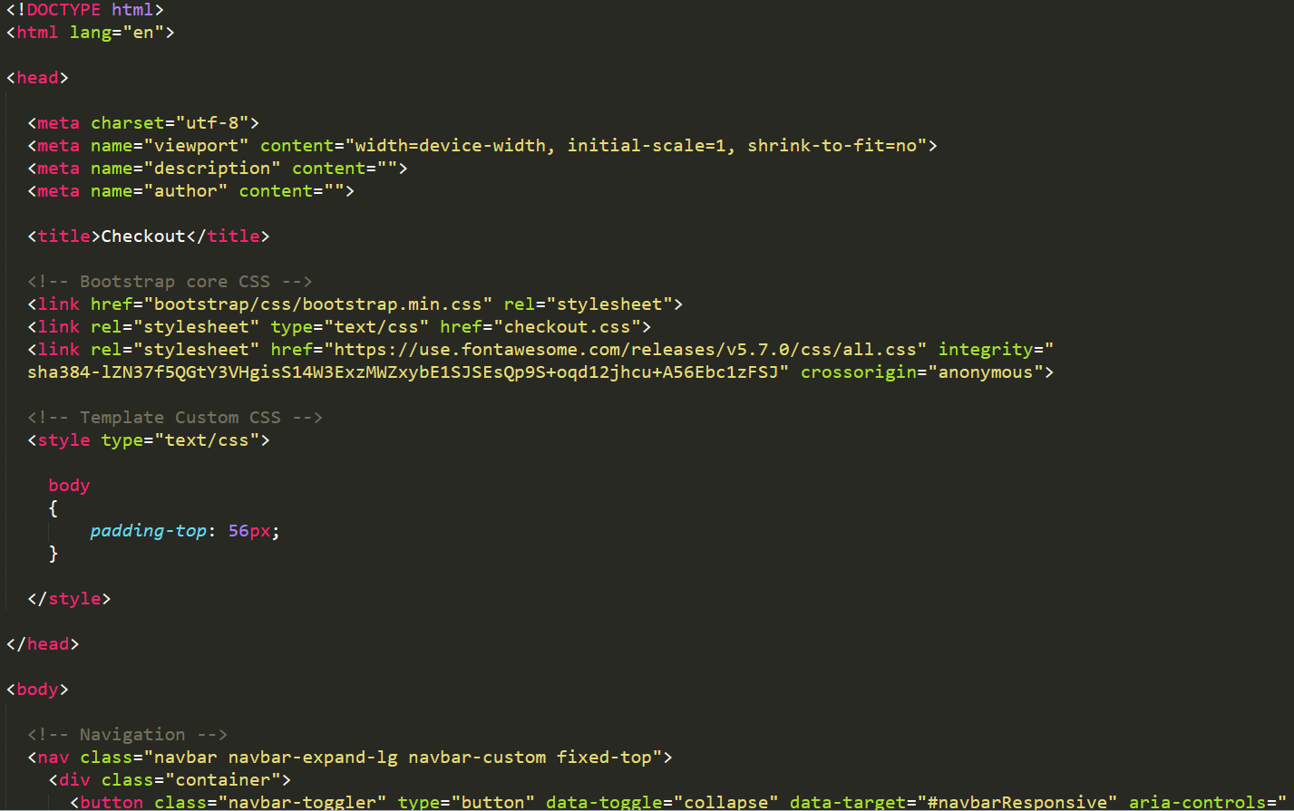

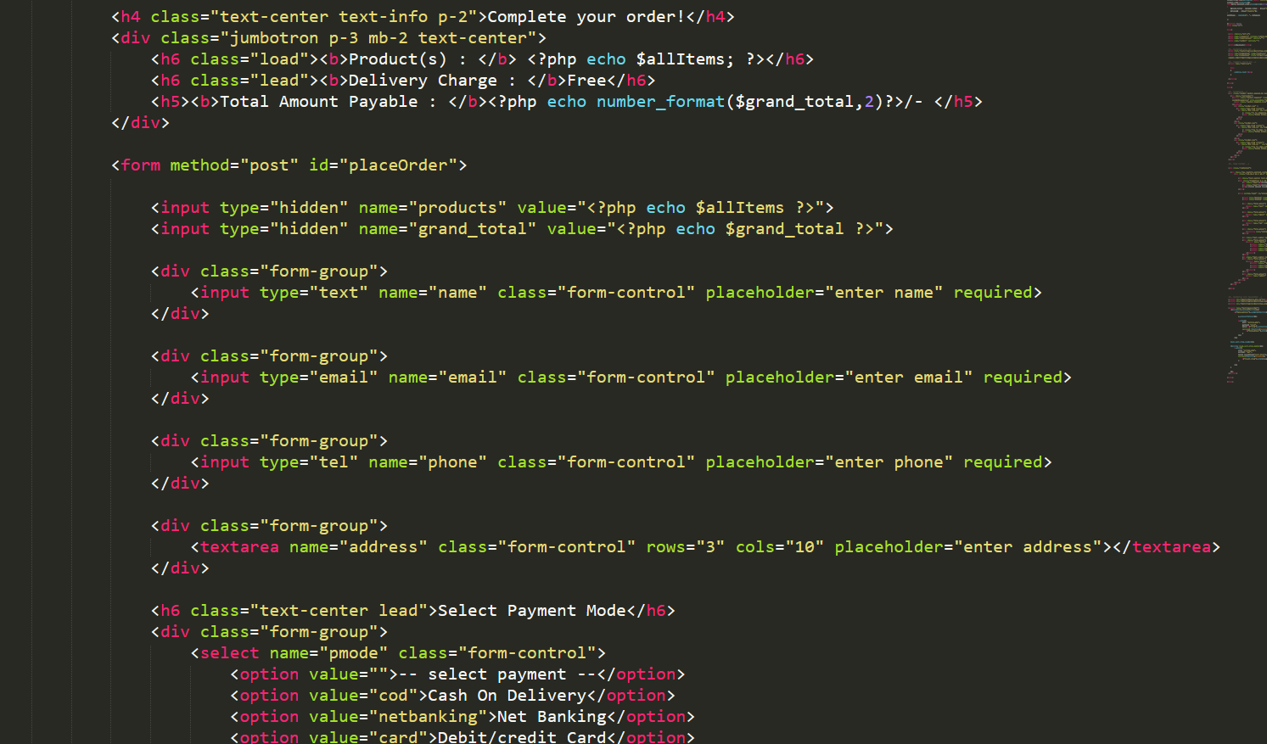

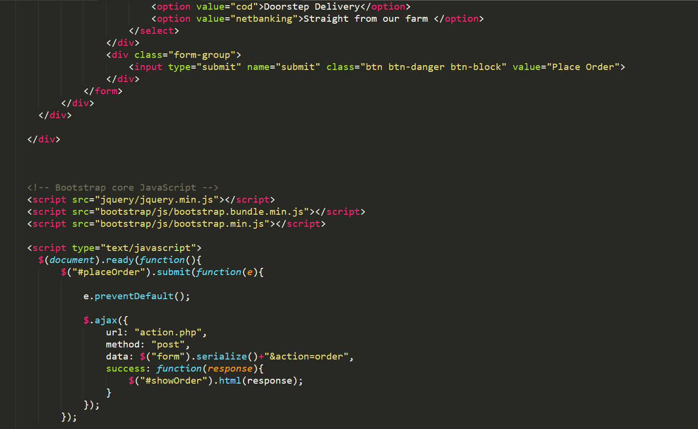

**Css:**

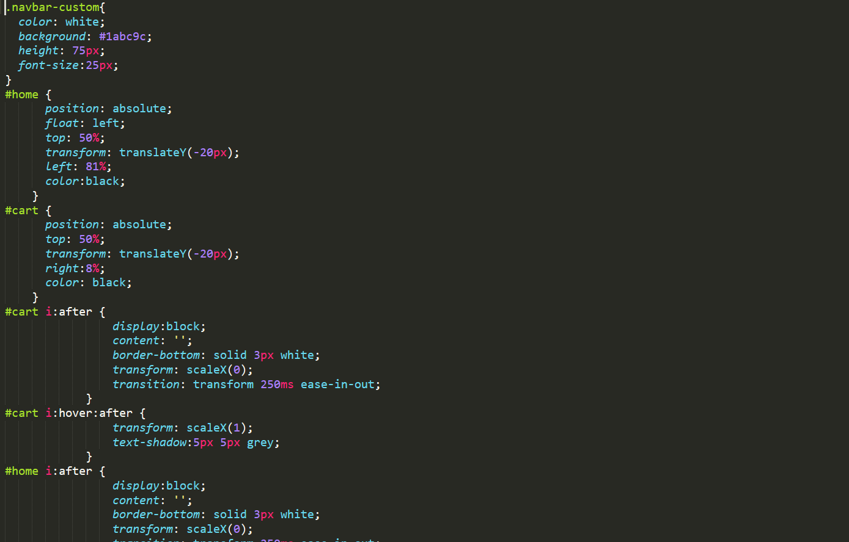

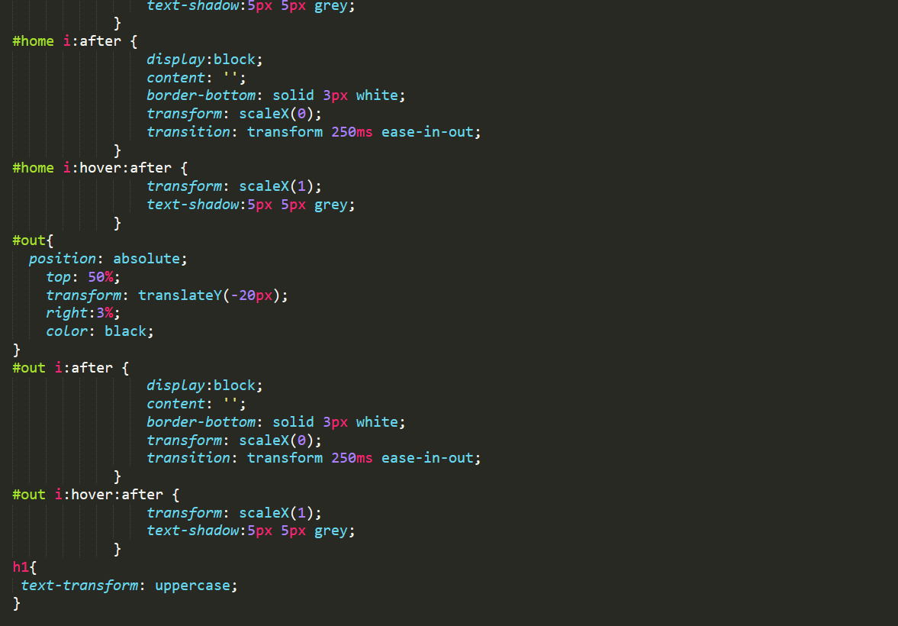

**CODE FOR CONNECTING THE SERVER :**

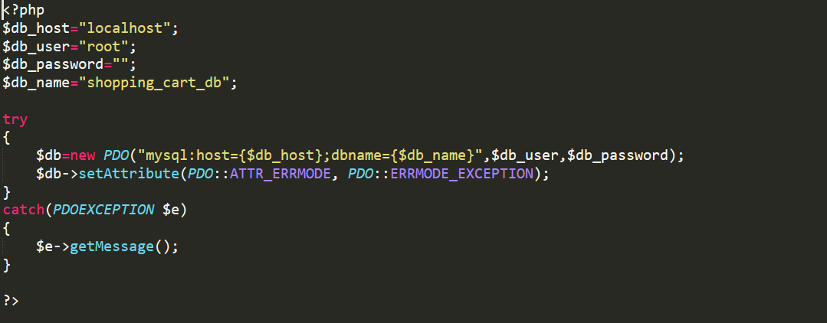

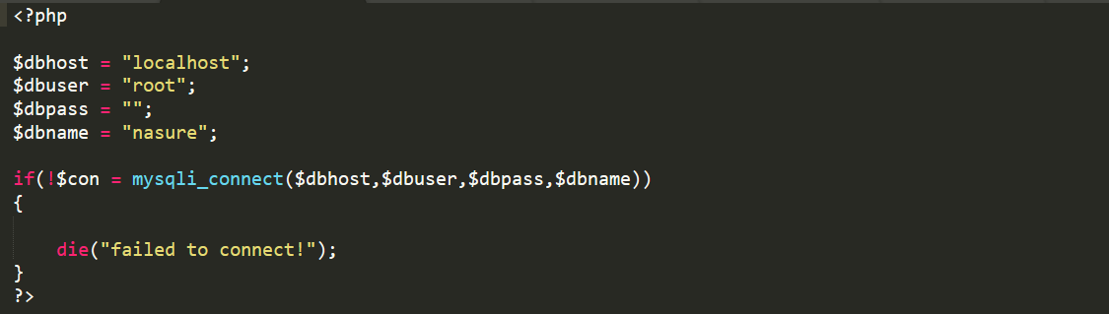

**CODE FOR RETRIVEING THE INFORMATION IN DATABASE:**

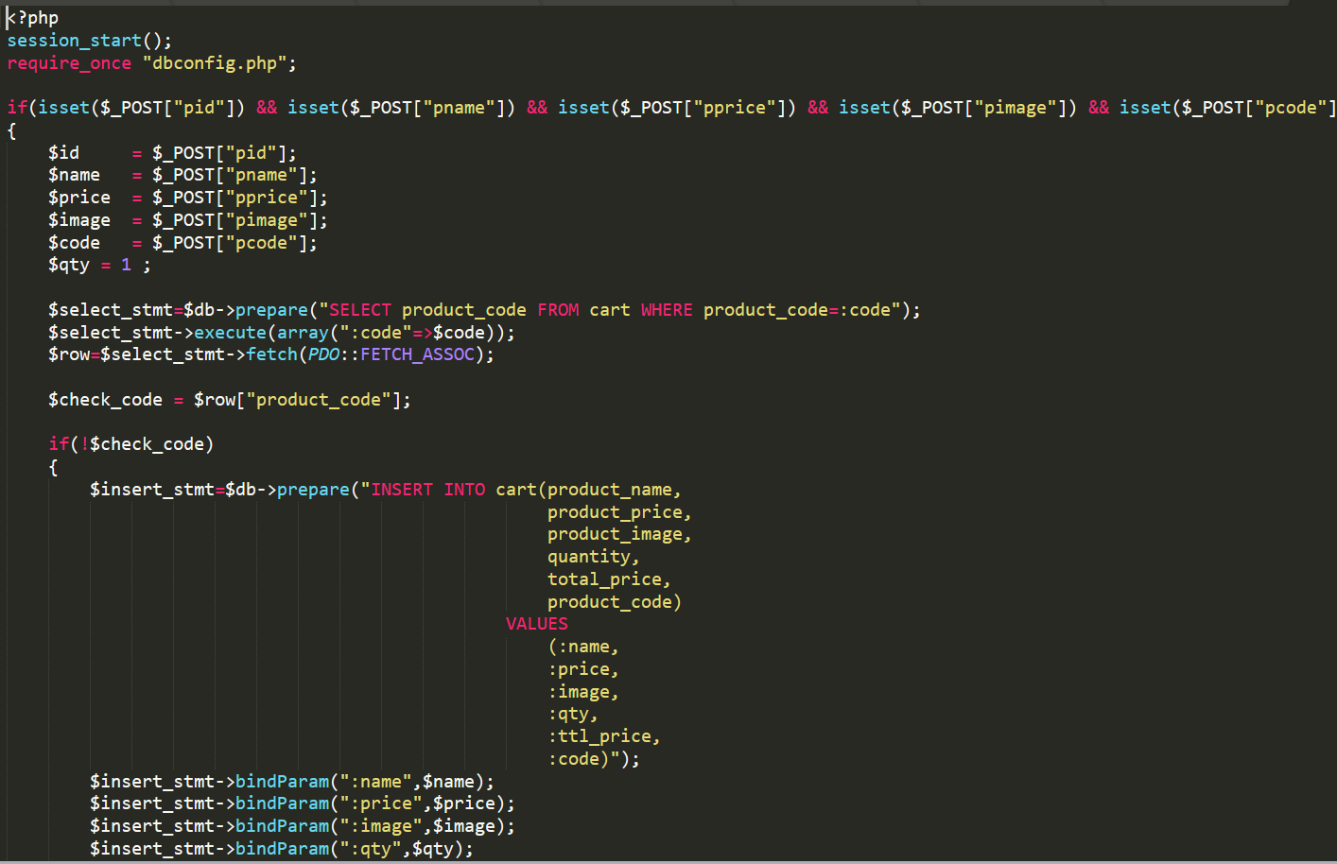

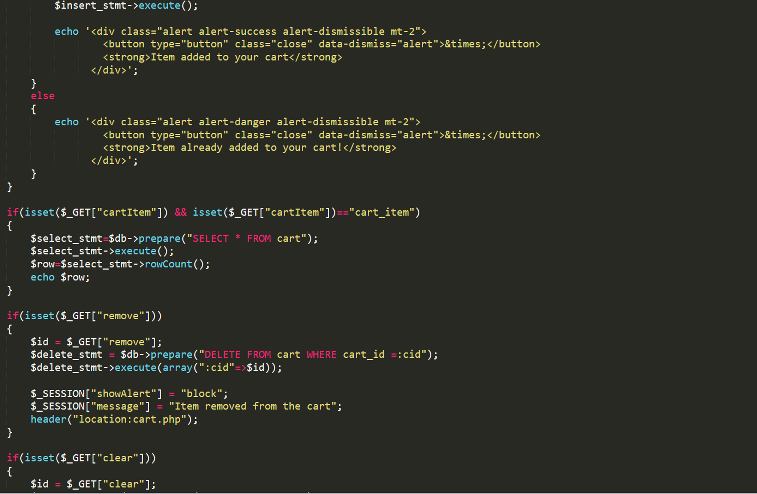

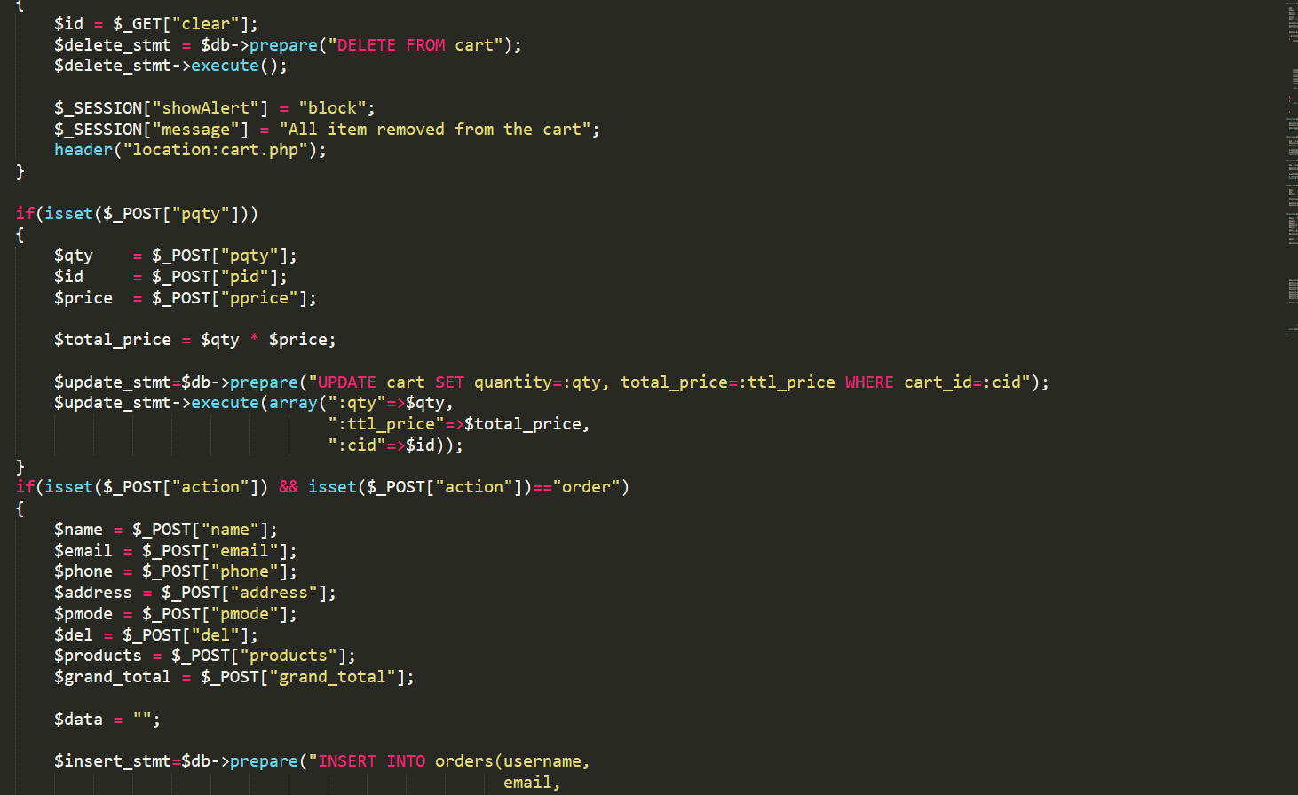 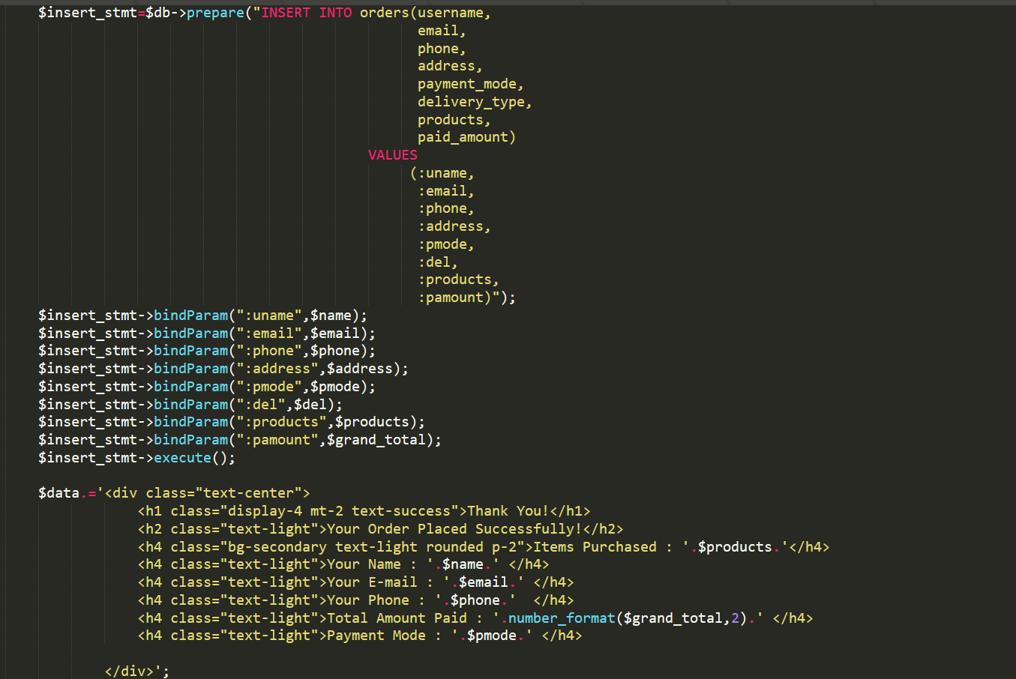

**CONCLUSION:**

**Nasure is an agri-portal which has been created to help out the farmers and the consumers in this pandemic. We also put the safety of our costumers prior, and the products are properly sanitized and given at your door.**

**Think Green, Live Green**

**REFERENCE:**

1. <https://www.youtube.com>
2. <https://www.w3schools.com/>
3. <https://www.w3resource.com/>
4. <https://www.onlyxcodes.com/>